

COLLEGE OF TECHNOLOGY

Master of Science

in

AVIATION AND aEROSPACE mANAGEMENT

Graduate Student Handbook

September 2014

This page is left intentionally blank.
Aviation and Aerospace Management (AAM) M.S.
Graduate Student Handbook

NOTE: This document supersedes the Graduate School Policies & Procedures Guide and the College of Technology Graduate Handbook.

TABLE OF CONTENTS

Page
FORWARD: HOW TO USE THIS HANDBOOK? ……………………………… 1
Contact Information ……………………………………………………….. 1
SECTION 1.0. INTRODUCTION ………………………………………………… 2
1.1. Background ……….…………………………………………………….. 2
1.2. Mission ……………………………………………………………… 2
1.3. Degrees ……………………………...………………………………… 2
SECTION 2.0. ADMISSION PROCESS ……………………………………….. 4
2.1. Requirements ……………………………………………………………. 4
2.2. English Requirement …………………………………………………… 5
2.3. Conditional Admission …………………………………………………. 6
2.4. Deadlines ……………………………………………………………..... 6
2.5. Time Limitation …………………………………………………………. 7
2.6. Financial Assistance …………………………………………………….. 7
2.6.1. Availability …………………………………………………… 7
2.6.2. Assistantship Appointments …………………………………. 7
SECTION 3.0. POLICY ON MONITORING, PROBATION, AND DISMISSAL 8
3.1. Minimum Cumulative GPA Requirements………………………. ………. 8
3.2. Monitoring ……………………………………………………………… 8
3.3. Probation ……………………………………………………………… 9
3.4. Dismissal ……………………………………………………………….. 9
3.5. Appeal ……………………………………………………………… 9
SECTION 4.0. MASTER’S DEGREE PROGRAM STRUCTURE ……………. 10
4.1. Program Credit Hour Requirements …………………………………… 10
4.2. Residency Requirements ……………………………………………….. 10
4.3. Appointment of a Major Professor/Advisor …………………………… 10
4.4. Graduate Advisory Committee ………………………………………… 11
4.5. Course Load Recommendations and Requirements ……………………. 11
4.5.1. Reduced Course Loads for International Students …………… 12
4.6. Registering for Courses as a Graduate Student ………………………… 12
4.7. Dropping and Adding Courses ………………………………………… 13

SECTION 5.0. ELECTRONIC PLAN OF STUDY REQUIREMENTS ……… 15
5.1. Primary Area …………………………………………………………… 16
5.2. Plan of Study Guidelines ……………………………………………….. 17
5.3. Related Area …………………………………………………………… 18
5.3.1. Undergraduate Credit in a Related Area …………………….. 18
5.3.2. Sources for Related Area Courses ……………………………. 18
5.4 Course Only Option .......………………………………………………… 18

5.5. Credit Limitations ……………………………………………………… 18
5.5.1. Undergraduate Excess Credit ………………………………… 19
5.5.2. Transfer Credit ……………………………………………….. 19
5.5.3. Post-baccalaureate Registrant Credit …………………………. 19
5.5.4. Independent Study Credit …………………………………….. 19
5.6. EPOS Acknowledgement of Thesis Requirement ………………………. 19
5.7. Examination Requirement ……………………………………………… 20
5.8. Examining Committee ………………………………………………… 20
5.9. Publication Requirement ……………………………………………….. 20
SECTION 6.0. INDEPENDENT STUDY REGISTRATION (AT 590) ……….. 21
SECTION 7.0. THE AAM THESIS ……………..………………………………… 23
7.1. The Master’s Thesis ……………………………………….……………. 23
7.1.1. Key Points about the Thesis ………………………………….. 23
SECTION 8.0. THESIS PROCEDURES ……………………………………….. 25
8.1. AT 698 Thesis Research Enrollment…………….. ……………………… 25
8.2. Grades for AT 698 Research MS Thesis…… ……………………………. 25
8.3. Thesis Proposal Defense ………………………………………………… 26
8.4. APA and Formatting Requirements Theses ……………………………. 26
8.4.1. Notes about the Templates ……………………………………. 26
8.5. Preparing Thesis Proposals ……………………………………………… 27
8.6. Thesis Proposal Contents ……………………………………………… 27
8.6.1. Thesis Cover Page ……………………………………………. 28
8.6.2. Abstract ………………………….…………………………… 28
8.6.3. Chapter 1: Introduction ……………………………………….. 28
8.6.3.1. Statement of the Problem …………………………... 28
8.6.3.2. Research Question/Hypotheses ……………………. 28
8.6.3.3. Significance of the Problem ……………………….. 29
8.6.3.4. Statement of Purpose/Scope ……………………….. 29
8.6.3.5. Definitions ………………………………………… 30
8.6.3.6. Assumptions ……………………………………….. 30
8.6.3.7. Limitations ………………………………………….. 30
8.6.3.8. Delimitations ……………………………………….. 31
8.6.4. Chapter 2: Review of Literature ………………….…………… 31
8.6.5. Chapter 3: Methodology ……………………………………. 32
8.6.6. List of References ………………………………. 33
8.7. Obtaining Permissions to Conduct Research ………………………….. 33
8.8. Preparing the Final Thesis …………………………………………….. 33
8.8.1. Final Thesis Contents ……………………………………….. 34
8.8.2. Chapter 4: Presentation of the Data and Findings …………… 34
8.8.3. Chapter 5: Conclusions, Discussion, and Recommendations ... 35
8.8.4. Appendices …………………………………………………. 35
8.9. Plagiarism, Falsification, and Fabrication …………………………….. 36
8.9.1. Plagiarism ……………………………………………………. 36
8.9.2. Strategies for Avoiding Plagiarism …………………………. 36
8.9.3. Guidelines for Quoting and Citing …………………………... 37
8.9.4. Purdue University Form 20: Research Integrity
and Copyright Disclaimer …………………………………… 37
8.10. Self-Checking for Plagiarism ………………………………………….. 37
8.10.1. Rules Governing Usage ………..…………………………… 37
8.10.2. Procedure for Using Check Yourself ………….……………. 38
8.11. Copyright Issues with Figures ………………………………………… 38
SECTION 9.0. POST-PROJECT/THESIS ACTIVITIES …………………….. 40
9.1. Appointment Of the Examining Committee & Scheduling the
Final Oral Examination ………………………………………………. 40
9.2. Declaring Graduation Candidacy ………………………………………. 40
9.3. Completing the AT 698 Requirement ………………….. 40
9.4. Formatting Review for Theses ………………………………………….. 41
9.4.1. Formatting ……………………………………………………. 41
9.4.2. Formatting Your Thesis ……………………………………… 41
9.4.3. Scheduling and Attending the Meeting ………………………. 42
9.4.4. Thesis Pre-review …………………………………………….. 42
9.5. The Oral Defense of the Thesis ……………………..………………….. 42
9.6. University Deposit of the Thesis ……………………………………….. 42
9.7. Departmental Deposit of the Thesis …………….……………………… 43
9.7.1. For Assistance with Submitting to the Purdue e-Pubs Site …… 43
9.8. Copies of Final Thesis for Graduate Committee ……………………….. 43
9.9. Additional Requirements for Graduation ……………………………… 44
9.10. Participating in Commencement ………………………………………. 44
9.11. Procedures for continuing to doctoral program......................................... 44
SECTION 10.0. OVERALL MASTER’S DEGREE PROCEDURAL
CHECKLIST ……………………………………………………………45
10.1. First Semester ………………………………………………….……….. 45
10.2. Succeeding Semesters ……………………………………………..……. 45
10.3. Final Semester ……………………………………………………..……. 46
SECTION 11: AT DEPARTMENTAL EXPECTATIONS FOR GRADUATE STUDENTS ………………………………………………………………………….. 47
SECTION 12: GRADUATE FACULTY IN AVIATION TECHNOLOGY .……. 48
SECTION 13: Potential Courses for aam Related Areas Outside the College of Technology ……………………………………….... 55

section 14: Potential Courses for aam Related Areas Within the College of Technology ……………………………………………. 57

APPENDIX A: REQUEST FOR REDUCED COURSE LOAD ………………….. 58
APPENDIX B: SAMPLE PLAN OF STUDY ………………………………………. 60
APPENDIX C: FLOWCHART OF EPOS PROCESS ……………………………. 63
APPENDIX D: FORM 1 -INDEPENDENT STUDY REQUEST FORM AND INSTRUCTIONS ………………………………………………………………… 65
APPENDIX E: FORM 23 …………………………………………………………… 67
APPENDIX F: AT FORM 2: ACCEPTANCE OF THESIS PROPOSAL ……..…..… 69
APPENDIX G: THESIS COVER PAGE …………………………………………… 71
APPENDIX H: CHECK YOURSELF REQUEST FORM …………………………. 73
APPENDIX I: GS FORM 8: REQUEST FOR APPOINTMENT OF EXAMINING COMMITTEE ………………………………………………………………… 75
APPENDIX J: GS FORM 7: REPORT OF MASTER’S EXAMINING
COMMITTEE ……………………………………………………………… 77
APPENDIX K: GS FORM 30: THESIS ACCEPTANCE ………………………….. 79
APPENDIX L: GS ETD FORM 32: ELECTRONIC THESIS DEPOSIT …………… 82
APPENDIX M: GS FORM 19: MASTERS THESIS AGREEMENT ……………… 85
APPENDIX N: GS FORM 15: REQUEST FOR CONFIDENTIALITY …………… 93

FORWARD: HOW TO USE THIS HANDBOOK?

This document is intended to clarify and emphasize the expectations that the Department of Aviation Technology has relative to the pursuit of graduate studies. You will find that content in this Handbook is similar to that of the College in most cases. Where there are differences, the Department of Aviation Technology has typically established procedures and rules that fall within, or are more stringent than, those of the College. Especially with regard to credit hours, courses to be taken, and important milestones towards graduation, the policies and procedures in this document may vary from that of the College. If you have questions about how to interpret what is in this Handbook, please consult with your major professor, the AT Graduate Program Chair, or the Aviation Technology Department Secretary.

Contact Information
Dr. Richard O. Fanjoy
AT Graduate Program Chair
Email: atgrad@purdue.edu
Phone: 765.494.9964

Shannon Cassady
AT Department Secretary
Email: scassady@purdue.edu
Phone: 765.494.5782

SECTION 1.0. INTRODUCTION

Section 1.0 of this document provides an overview of general information concerning graduate study in Aviation and Aerospace Management.

Background
The forecast for an expanding air transportation network in this country supports a continuing increase in the need for managers in the aviation and aerospace industry. The Bureau of Labor Statistics Occupational Outlook Handbook (2010) suggests the number of air transportation industry workers will increase by 7.5%, airline pilots and flight engineers by 11.8%, and management, business, and financial occupations by 11.4% over the period 2008 to 2018. In addition, economic forecasts suggest that a steady increase in traveling passenger and air cargo requirements will fuel a dramatic expansion of the aviation industry, and require a complete restructure of the existing air transportation system architecture. This industry growth is generating a wide range of leadership opportunities in the aviation industry for individuals who possess aviation and aerospace management skills such as operational analysis, safety systems development, project management, systems integration, environmental sustainability, and related interdisciplinary skills. In an effort to promote intellectual inquiry and to stimulate a recognized body of applied research, aviation and aerospace management graduate study in the Department of Aviation Technology focuses on four broadly based, interrelated branches including safety systems management, aviation human factors, aviation operations, and global aviation systems. The subject matter associated with these focus areas will prepare graduates for middle and upper management positions with airport management and development agencies, passenger and cargo airlines, aircraft maintenance operations, air traffic control agencies, aviation financial companies, aviation-related manufacturers and suppliers (aircraft, engines, fuels, and components), and local, state and federal aviation agencies.

1.2. Mission
The mission of the graduate program in Aviation and Aerospace Management is to prepare graduates for leadership positions in the aviation industry and to advance the development and application of aviation and aerospace management through applied research, publishing, and presentations.

1.3. Degrees
Graduate study leading to the Master of Science in Aviation and Aerospace Management is offered through the Department of Aviation Technology in the College of Technology at Purdue University. This degree program requires a thesis concentrating on applied research. A course only program option is also available. Outstanding undergraduates in their third year of study in the Aviation Technology Bachelor of Science program may apply for a combined degree program. The combined degree allows a student to obtain the B.S. and M.S. degrees within five years.

A Ph.D. degree program with a general technology focus and concentration in aviation and aerospace management is offered through the College of Technology. This program option allows opportunities for professional development in educational applications of aviation and aerospace management. A separate handbook provides detailed information for the doctoral program. It can be found at the following web address: https://tech.purdue.edu/sites/default/files/files/COT_PhD_Graduate_Handbook_Aug_2013.pdf

Specific information about graduate study in Aviation and Aerospace Management may be obtained directly from the Department of Aviation Technology, 1401 Aviation Drive, Purdue University, West Lafayette, IN 47907. The telephone number is 1 (765) 494 5782. You may also visit us on the web at https://tech.purdue.edu/degrees/ms-aviation-and-aerospace-management

SECTION 2.0. ADMISSION PROCESS
Section 2.0 of this document provides an overview to the requirements, types of admission, time limits and opportunities for financial assistance relative to graduate study in Aviation and Aerospace Management.

2.1. Requirements
The Department of Aviation Technology Graduate Admissions Committee reviews several important criteria in a holistic fashion when evaluating an application for graduate study. In addition to completing a bachelor’s degree before admission to graduate studies, the following criteria are considered when reviewing an applicant’s request for admission:

- GRE Scores: The committee looks at GRE scores in two different ways. Scores at or above the 50th percentile serve as a goal for unconditional admission. The Analytical score on the GRE should be at or above 4.0 for the revised version of the GRE, or at or above the 50th percentile for the older version. Applicants with scores below this goal may still be accepted if other application materials indicate a high probability of program success.
- Statement of Purpose: This document should include the applicant’s professional goals and objectives as they relate to applied research and advanced coursework in aviation and aerospace management. It should not appear that an applicant wants to simply take content similar to their undergraduate curriculum and receive graduate credit for such work.
- Previous GPA: There is no minimum GPA required for admission outside those set by the Graduate School at Purdue University and the College of Technology, which is 3.0. A lower GPA will not disqualify a candidate but may lead to a more in-depth examination of the applicant in regards to the other admissions materials or it may lead to conditional admission.
- Letters of Recommendation: Letters of recommendation should come from at least three (3) people that can attest to the applicant’s professional abilities, goals, and background as it relates to aviation and aerospace management. These letters should also speak to the applicant’s professional maturity and academic ability. For applicants that have been in the workforce for several years, positive letters of recommendation attesting to the candidate’s knowledge gained while on the job are also helpful.
- Professional Experience: Consideration will be given for internships, co-ops, or professional work experience and their relationship to the applicant’s undergraduate degree program and the candidate’s Statement of Purpose for admission to graduate school. Work experience that offsets potential deficiencies in their academic background will be favorably noted.
- Nature of Academic Coursework: Consideration will be given to the applicant’s undergraduate coursework and its inherent rigor. An applicant’s profile should contain examples of proficiency within the AT graduate program focus areas of: aviation operations, safety management systems, human factors, and global aviation systems. The AT Graduate Admissions Committee may use this record as a guide for determining any potential conditions for admission related to coursework.
- Graduate Core Competencies: The applicant should appear to possess the ability to become proficient within the AT department’s graduate core competencies during their course of study. These include:
  - Conceptual Competence (breadth of business/management knowledge)
  - Analytical Competence (critical thinking, methodologies, data analysis)
  - Communications Competence (written and spoken formats)
  - Responsible Conduct of Research (responsible/ethical research methods)
  - Social Responsibility (environment and diversity considerations)

- International applicants must also submit TOEFL scores. While there are no minimum GRE requirements, the University’s Graduate School web site lists the specific minimum TOEFL score requirements for language proficiency.

Only after all the necessary materials have been assembled by the Aviation Technology Graduate Studies Office will they are forwarded to the graduate admissions committee for consideration.

Admission recommendations from the AT Graduate Admissions Committee will be one of the following:

- Admit without conditions,
- Admit with conditions (and these conditions must be specified), or
- Deny admission.

2.2. English Requirement
The Graduate School of Purdue University requires that all students demonstrate proficiency in the English language before a graduate plan of study may be filed. There are three ways to meet this requirement.

- Earn no grade lower than “B” in all undergraduate English composition courses; or
- Obtain a score of 50th percentile or higher on the Verbal Aptitude Section of the Graduate Record Examination (GRE); or
- Satisfactory performance on the Oral English Proficiency Test (score of 50 or better) or satisfactorily complete ENGL620.

Non-native English speaking applicants must provide TOFEL scores as part of their application package.

2.3. Conditional Admission
Occasionally, a student who does not meet the standard for unconditional admission may be recommended for conditional admission, provided evidence is presented (e.g., a high performance on the Graduate Record Examination or strong professional experience) which indicates that the student’s potential for success is not adequately reflected in their academic record.

An applicant having interest in the aviation and aerospace management discipline may not have the aviation industry or analytical foundations necessary to go directly into the graduate program. A prospective applicant for graduate study in this discipline who does not have relevant formal education, training, or experience may be required to complete certain undergraduate courses as directed by the AT Graduate Admissions Committee. Such courses will not be available for use on the Master’s degree plan of study and must be taken before enrolling in graduate-level program courses.

Conditional admission requires that certain minimum performance standards be specified and met, such as “must achieve at least a 3.00/4.00 graduate index at the completion of the first twelve (12) credits following admission to the Master’s degree program.” Any conditions placed on the applicant’s acceptance into the program will be monitored by the student’s major professor and the AT Graduate Chair. Failure to meet conditions of acceptance will result in actions taken by the AT Graduate Chair to place the student in probationary academic status. Such status will be communicated to the Graduate School and each semester the Graduate School will remove the eligibility to register for future sessions for all students who failed to satisfy their conditions of admission in the previous session. (Thus, there is a grace period of one semester). Failure to improve academic performance once placed on probation will result in the dismissal of the student from the AAM graduate program (see section 3.0 for information regarding probation and dismissal).

The AT department may consider any requests to have a student’s eligibility to register for classes restored. Such requests are made by the student’s major professor with a memo through the AT graduate chair to the graduate school, detailing reasons why the student should be permitted to continue. Upon Graduate School approval, the eligibility to register will be restored.

2.4. Deadlines
The deadlines for completed applications are shown in table 2.1.

Table 2.1.
Current Deadlines for Program Application (subject to change by the Graduate School).

Domestic Applicants | International (outside the U.S.) | International (within the U.S.)
Fall - April 1  Spring - October 1  Summer - April 1 | Fall - April 1  Spring - September 1  Summer - February 1 | Fall - April 1  Spring - October 1  Summer - April 1

2.5. Time Limitation
A candidate for the Master's degree is expected to complete all requirements for the degree within five years from the completion of the oldest course on the plan of study. The goal for full-time students would be to complete in two academic years.

2.6. Financial Assistance
The following two sections describe the availability of financial assistance and information about assistantship appointments.

2.6.1. Availability
A limited number of graduate teaching and research assistantships within AT are available on a competitive basis. All assistantship applications are to be directed to the AT Graduate Chair. Additional appointments are available from other departments of the University, such as the Information Technology at Purdue (ITaP), the library system and student housing. Details on assistantships and fellowships outside the AT department are available at Purdue University’s Graduate School web site at http://www.gradschool.
purdue.edu/funding/.

2.6.2. Assistantship Appointments
In order to provide an opportunity for the student to progress satisfactorily toward a degree objective, graduate appointments will ordinarily be for no more than one-half time (20 hours per week) and for a maximum of two (2) academic years. Renewal of graduate appointments for additional time will be based on satisfactory performance in the position and academic performance toward plan of study requirements, as well as availability of positions.

Teaching assistantships (TA) and Research Assistantships (RA) include a tuition waiver during the semester the student has the assistantship. Normally, teaching assistantships are not available in the summer. However, if a student has a teaching assistantship in the spring and the following fall semester, a tuition waiver for the summer is still available to the student.

NOTE: Assistantships DO NOT cover the cost of student fees assessed each semester.

SECTION 3.0 POLICY ON MONITORING, PROBATION, AND DISMISSAL

Section 3.0 provides an overview to the monitoring, probation, dismissal and appeal policies in the Department of Aviation Technology.

3.1. Minimum Cumulative GPA Requirements (in graduate courses)
The Department of Aviation Technology has specific GPA requirements for graduation as shown in Table 3.1. Typically these mimic the University requirements. Also shown are the GPA requirements for probation and dismissal relative to the department’s programs. Sections 3.2 thru 3.5 outline the policies and procedures relative to probation and dismissal.

Table 3.1. Graduation, Probation and Dismissal GPA Thresholds

Graduation | 3.00/4.00
Probation | 2.75/4.00
Dismissal | 2.50/4.00

NOTE: University requirements state that no grade of “D” or “F” is allowed in a course on the graduate plan of study. Any plan of study course in which a grade of “D” or “F” is received must be repeated and completed successfully; it cannot be dropped from the plan of study.

3.2. Monitoring
Each semester graduate student performance is evaluated to ensure that the student is performing well and will graduate with a 3.00/4.00. Procedurally this is done in the following way:

- Graduate student grades and academic progress will be monitored in the AT Office of Graduate Studies.
- Monitoring will begin after six (6) credit hours have been attempted and every semester thereafter in which the student is enrolled.
- Students are expected to maintain a cumulative grade point average of at least 3.00 /4.00 with no grade less than “B” and earn grades of “Satisfactory” in thesis research credit hours.

NOTE: The grade “B-" (B minus) is below the expected grade graduate student should earn in his or her courses.

- If a student has a semester GPA less than 2.75/4.00 or a cumulative GPA less than 3.00/4.00, a letter will be drafted by the Chair of the AT Graduate Program to the student, with a copy to the major professor, to the AT Department Head, to the Graduate School, and to the student’s file, indicating the last semester was determined unsatisfactory and that they are being placed on probation.

NOTE: Graduate students that receive an incomplete in a course will have one semester and 12 weeks into the following semester to complete the course. If that is not done, the Registrar automatically makes the grade a failure.

3.3. Probation
Probation occurs when a student performs below the AT standards in an individual semester. Procedurally probation means:

- If a student’s semester GPA falls below 2.75 or if a student’s cumulative GPA falls below 3.00/4.00, the student will be placed on academic probation.
- The AT Graduate Studies Office will generate a letter informing the student, major professor, and department head of the probationary status. A copy will also be forwarded to the Graduate School and placed in the student’s permanent record.
- The student will have one semester to raise their cumulative GPA to the required level and return to good standing. If they do not, they will not be able to register for classes the subsequent semester and will be dismissed from the program.
- While on probation, students are ineligible for an AT assistantship.

3.4. Dismissal
- If a student’s semester GPA is below a 2.50 or if a student’s cumulative GPA falls below 2.75, the student will be immediately dismissed from the program.
- A student will be dismissed from the program if they remain on probation for two consecutive semesters without improvement. This policy is independent of any assistantship the student may hold.

3.5. Appeal
- A student may appeal their probationary or dismissal status by contacting the AT Graduate Studies Office in writing within thirty (30) days of the date of the requisite notification letter. The appeal should include the student’s specific reasons for exception to the aforementioned policies.
- The appeal will be reviewed by a subcommittee of at least three (3) members of the AT Graduate Committee, chaired by the AT Graduate Program Head.
- If the review committee recommends reinstating the student, the student’s major professor must approve. If the major professor does not approve, the AT Department Head will render a final decision.
- In cases where a student is reinstated without approval of the major professor, a new major professor may need to be assigned.
- The decision of the appeal subcommittee and/or AT Department Head will be considered final and will be delivered within thirty (30) days of the student’s request for exception to probation.

SECTION 4.0. MASTER’S DEGREE PROGRAM STRUCTURE

Typically the Master of Science in AAM degree requires that each student complete the requisite number of courses and successfully execute a thesis (a course only option is available). Typically, proposal of the thesis occurs in the next to last semester of study (but this can vary). As a process, the Master of Science with thesis includes:

- Coursework (27 credit hours)
  - Appointment of major professor
  - Selection of a committee (two people in addition to a chair)
  - Filing of the Electronic Plan of Study (EPOS)
    - Draft of the Plan of Study must be submitted by the end of the first semester of study.
    - A final Plan of Study must be submitted by the end of the second semester of study.
  - Successful completion of all courses
- Thesis
  - Thesis proposal and proposal defense meeting
  - Obtain appropriate certifications for research (CITI, HIPAA, FERPA, etc.).
  - Execution of thesis
  - Final oral defense of thesis

Students who choose the course-only option will replace the thesis requirement with an additional 6 credits of course work, including a small-scale independent study.

4.1. Program Credit Hour Requirements
The Master's degree program administered through the Department of Aviation Technology requires a minimum of 27 credit hours of course work and six (6) hours of thesis research (AT 69800). The thesis must be defended through a public oral defense and examination meeting with the faculty advisory committee and any other interested parties. Students who choose the course-only option will replace the thesis requirement with an additional 6 credits of course work, including a small-scale independent study.

4.2. Residency Requirements
The total number of hours of academic credit used to satisfy residency requirements consists of all course credit hours that appear on the plan of study, other graduate course credit hours with grades of “C” or better that appear on the Purdue transcript, and research credit hours with grades of “S” that appear on the Purdue transcript. In fulfilling these requirements, a maximum of 18 credit hours will be allowed from any one semester (maximum hours are proportional to length of summer session = 9 credit hours).

4.3. Appointment of a Major Professor/Advisor
Each graduate degree plan of study is unique to the individual student and his/her background, experience, and degree objectives. To guide in the development of a degree plan, a major professor (advisor) will be appointed to chair the student's advisory committee and will assist the student through the program. A student may request a major professor in their application materials; but this person may not always be available, based on advisement load, research commitments, and other factors. The major professor will become the most important contact person, and the major professor/student relationship must be a mutually acceptable one. The major professor serves concurrently as advocate, mentor, and supervisor of the graduate student.

NOTE: A student may change major professor if their research topic changes significantly as a result of his or her course of study. If this is the case, the student should discuss this with the current major professor and modify the Electronic Plan of Study (EPOS) accordingly.

4.4. Graduate Advisory Committee
Each student, with assistance and approval from the major professor, is responsible for establishing an advisory committee for his or her program. The duties of that committee are to advise the student in the preparation of the plan of study and to offer advice and assistance during the period of graduate work.

The committee consists of the major professor, at least one other member of the AT graduate faculty (refer to section 4.3 and 4.4 of this handbook), and an advisor from a related area in the plan of study (who must also be a member of the Purdue University graduate faculty). Members of the committee need not be faculty with whom the student has taken course work. However, in practice this is usually the case. The request for appointment of the advisory committee is made on the same form (GS Form 8), and at the same time, as the request for approval of the student’s plan of study (refer to section 5.0). Each graduate student is encouraged to explore coursework areas outside the College of Technology that relate to their professional goals and development.

The advisory committee is selected and established once the student has a firm idea of their potential research direction. This typically occurs in the first semester. The committee will then be in place to help the student develop a plan of study and discuss the student’s thesis proposal, which must be approved before actual work on the project or research may begin.

NOTE: The thesis proposal must be approved prior to the semester the student intends to graduate.

The student should discuss the plan of study with their advisory committee members and get their permission to list them on the plan of study before the plan is submitted in final version online. Should the need arise after the final plan of study has been submitted; changes in the advisory committee will be handled on an individual basis through the Electronic Plan of Study form (EPOS) (refer to section 5.0).

4.5. Course Load Recommendations and Requirements
The maximum course load for graduate students is 18 credits. Typically 18 credit hours translate into six (6) courses. Eight (8) credit hours is considered the full-time certification standard for graduate students by the Graduate School.

NOTE: To maintain full time status, international graduate students must take at least eight (8) credit hours per semester.

Most students inquire as to how many classes they should take when they have an assistantship. Table 4.2 provides some recommendations as to how many credit hours are typical when also working as a teaching or research assistant.

Table 4.2. Recommended Course Loading for Assistants

Assistantship Load | Recommended Course Load
¼-time assistant | 9 to 12 cr. hrs.
½-time assistant* | 9 to 12 cr. hrs.
¾-time assistant | 6 to 9 cr. hrs.
*Assumes ½-time is equivalent 20 working hours.

NOTE: A candidate for the Master's degree is expected to complete all requirements for the degree within five years from the completion of the oldest course on the plan of study. Normally students complete within 2 years.

4.5.1. Reduced Course Loads for International Students
To maintain visa status, international students are expected maintain a full-time load. Purdue’s Office of International Students and Scholars (ISS) provides information about this requirement and offers a means for international students to request permission to take a reduced courses load. Appendix A provides a visual example of the form. Graduate students desiring a reduced course load should work with ISS to request this before their course load is reduced below that required by U.S. Immigration rules. See the ISS web site for more information: http://www.iss.purdue.edu/.

4.6. Registering for Courses as a Graduate Student
Purdue University provides online scheduling of courses for all of its students via the myPurdue system. The software used for this system is called Banner. Typically the student works with his or her major professor to determine the appropriate courses to take for a given semester. Students typically self-register. A registration PIN number is required to perform self- registration. You will be informed of your PIN number at the time of admission from the AT Graduate Office. However, at times students may need an ‘override’ to be able to register for certain courses. Such overrides can be facilitated by the AT academic advisors. More information about registering for classes can be found at the Registrar’s web site: http://www.purdue.edu/registrar/Students/.

It is the graduate student’s responsibility to keep track of specific dates relative to course scheduling. These include deadlines for registration, deadlines for dropping courses and the like. The Graduate School announces these dates on its web site and typically the deadlines are emailed to students each semester at appropriate times.

4.7. Dropping and Adding Courses
To drop or add a course, the student uses the myPurdue system. Changes to variable credit courses may be completed with assistance from the AT Graduate Office. Subsequently, be sure to confirm that a dropped or added course has been officially recorded by checking myPurdue.

Courses dropped during the first two weeks of classes will not appear on your permanent record. Courses dropped during weeks three and four will be recorded as a “W” grade on your permanent record (withdraw). Courses dropped during weeks five through nine require the signature of both the instructor and the AT Graduate Coordinator or Chair. In such a case, the instructor must assign a grade of “W,” “WF,” or “WN.” The end of this period is the final deadline for withdrawing from a class.

NOTE: A “W” simply records the fact that the student withdrew after the second week of the semester. A “WF” records that the student was failing a graded course. “WF” grades are not included in computing the GPA. A “WN” records failing status in a course being taken Pass/No Pass. “W,” “WF,” and “WN” grades are recorded on your permanent record.

Courses added during weeks two through four require the approval and signature of the instructor and the AT Graduate Program Chair. Courses may be added during weeks five through nine, but only under extraordinary circumstances. Courses added after the fourth week require the approval and signature of the instructor, the AT Graduate Program Chair, and the head of the department where the course is offered (for non-CoT courses).

NOTE: Graduate students who received an incomplete for a course will have one semester and 12 weeks into the following semester to complete that course. If not completed within that time frame, the Registrar automatically makes the grade a failure.

4.8 Combined BS/MS (3+2) Program
The Five-Year combined B.S.-M.S. Degree Program enables outstanding resident students to complete the B.S. and M.S. degrees in a total of five, rather than the usual six or more years. The program entails no alteration to the requirements for either degree, but does allow students to dual count up to nine credits of AT graduate level courses toward both degrees, which reduces the total time for the M.S. degree. Interested students should consult their academic advisor as early as possible on how to arrange their B.S. program of study so as to reduce the number of particularly demanding AT and non-AT courses left to be completed during your senior year. That will make the senior year course load more reasonable since they will be also completing graduate courses at that time.

At the beginning of the sixth semester of an eight semester BS program (2nd semester junior year), qualified students should apply to the graduate program and begin graduate study the following semester. Requirements for admission to the BS/MS program include a minimum 3.5 GPA for completed AT courses, a cumulative Purdue GPA of at least 3.2, and projected completion of at least 93 of the 124 credits required for graduation by the end of semester six in an AT B.S. plan of study. Graduate Record Examination (GRE) scores will not be required for this special program.

4.9 Non-resident Online MS Program
A version of the Aviation and Aerospace Management MS degree is available online through Purdue Continuing Education. Since this program is 100% distance learning, an MS degree at can be completed at an individual pace, from anywhere in the world, choosing times for class work and study that fit a student’s lifestyle. Courses are offered in a rolling format that allows completion of the 33 required credit hours in five to 10 semesters, with professors available online or by phone to assist. Typical course topics include human error and safety, measurement and evaluation, operational assessment and improvement, economic decision making, and ICAO Regulatory Systems. A capstone research project is required as part of the coursework. Program fees are $750 per credit hour for Indiana residents and $775 per credit hour for out of state residents.

SECTION 5.0. ELECTRONIC PLAN OF STUDY REQUIREMENTS

The philosophy of the Purdue University Graduate School is that advanced study should be tailored to the individual and his/her professional and intellectual objectives. Thus, the plan of study is unique to each student's needs and desires. To facilitate such an individually tailored program, each Master’s degree plan of study consists of a primary area and one or more related areas. Both the primary area and the related area(s) are based on the relationship of the course content and not necessarily on the departmental course prefix.

The development of the plan of study begins as part of the initial course registration. The major professor will discuss the student's background, interests, and degree objectives as part of the preparation for the first enrollment. The major professor will also recommend possible related areas and advisors.

In addition to course work requirements, each student must complete and successfully defend a research project known as Thesis (AT 698, Research MS Thesis. The plan of study should be developed to support this research requirement. A course only option may be elected in place of the thesis.

The plan of study must list all courses the student will take to meet the degree requirements. These include the names for the primary and related areas of study; the course number, course title, and credits for each course; the date when the course was or will be completed; and the research area. Research credits are listed in the notes field of the EPOS. The plan of study is electronically approved by each member of the advisory committee and the student. After review, the plan is signed by the AT Graduate Studies office. The plan is then submitted to the Graduate School for formal approval. It is important that the major professor access the approved plan of study and periodically review progress of its completion with the graduate student. After an approved Plan of Study is on file, committee and course changes can be made at any time up until graduation. This can be accomplished by clicking on the Create Change Request link available next to an Approved plan of study. The Change Request link will initiate a Change Request form. These procedures all occur electronically via the EPOS procedure. Refer to the following link:

https://ias.itap.purdue.edu/gradsch/HELP_PAGES/pos_student_instructions.doc

Also, be sure to review the AAM Plan of Study Checklist to verify completeness of your EPOS before submitting it in final form:

http://www.tech.purdue.edu/at/academics/graduate/documents/AAM_MS_POS_Checksheet_2011.pdf

Upon approval by the Graduate School, the plan of study becomes a contract among the student, the AT department, and the Graduate School. When all requirements of the plan of study are completed satisfactorily, the student is awarded the Master of Science (M.S.) degree. Refer to the sample plan of study form in Appendix B. Appendix C shows a flowchart of the EPOS creation and approval process.

NOTE: If a course in the plan of study is not available when the student needs it, or if the direction of the student’s research topic changes, students can submit an EPOS change of plan of study. Once filed, the change request requires prior signatories to approve the requested change.

5.1. Primary Area
All plans of study will have a primary area focused in Aviation and Aerospace Management. The primary area will have an applied research, management, or teaching emphasis. The plans of study require 33 semester hours (including the six (6) semester hours in AT 69800 Research MS Thesis), with a minimum of 12 semester hours in courses from AT. Students should contact their major professor (committee chair) to determine which section of AT69800 to enroll in. The student should enroll in the section offered by their major professor. The primary area for the Master of Science in Aviation and Aerospace Management with thesis option must include the following core courses (or acceptable equivalents):

Number Credits Title
STAT 501 3 Experimental Statistics I (IT 507 or STAT 511)
TECH 646 3 Analysis of Research in Industry and Technology

Courses included in the primary area (other than the required core courses above) should be selected to enhance the career goals of the student. Undergraduate courses may not be included in the primary area of the plan of study without special permission from the AT Graduate Committee. In addition to these required courses, students must include at least 9 credits of AT Primary Area Selective in their EPOS. Courses currently being offered by the faculty in Aviation Technology include:

AT 50500 Research Methods in Aviation
AT 50600 Capstone Research Project
AT 50800 Quality and Productivity in Technology
AT 52000 Operational Effectiveness and Assessment
AT 52100 Resource Analysis and Optimization
AT 52400 Managerial Economic Decision Making
AT 52500 Process Improvement and Simulation
AT 52600 Aviation Leadership
AT 52800 Management and Design of Training Systems
AT 53000 Multicultural Team Operations
AT 53100 ICAO Regulatory Systems
AT 53200 Contemporary Issues in Transportation Security
AT 54000 Aviation and Aerospace Sustainability
AT 54200 Aviation Fuels and Exhaust Emissions
AT 54400 Aircraft Lifecycle Management Innovations
AT 54600 Aviation Financial Instruments and Operations
AT 55000 Critical Systems Thinking
AT 57200 Human Error and Safety
AT 57300 Managing the Risk of Organizational Accidents
AT 57400 Concepts of Aviation Human Factors
AT 57500 Aviation Safety Program Development

5.2. Plan of Study Guidelines
Table 5.1 Provides guidelines for the Plan of Study.

Table 5.1
Plan of Study Guidelines
AAM Core Courses: | 6 credit hours
STAT 50100 (or equivalent) | Experimental Statistics I
TECH 64600 | Analysis of Research in Industry and Technology
AAM Primary Area Selectives: | 15 credit hours
AT 50500  AT 50600  AT 50800 | Research Methods in Aviation  Capstone Research Project  Quality and Productivity in Technology
AT 52000 | Operational Effectiveness and Assessment
AT 52100 | Resource Analysis and Optimization
AT 52400 | Managerial and Economic Decision Making
AT 52600  AT 52800 | Aviation Leadership  Management and Design of Training Systems
AT 53000 | Multicultural Team Operations
AT 53100 | ICAO Regulatory Systems
AT 53200  AT 54000 | Contemporary Issues in Transportation Security  Aviation and Aerospace Sustainability
AT 55000  AT 57200  AT 57400  AT 57500 | Critical Systems Thinking  Human Error and Safety  Concepts of Aviation Human Factors  Aviation Safety Program Development
AAM Related Area Options: | 6 credit hours (minimum)
Thesis Research | 6 credit hours

5.3. Related Area
Each plan of study must include a related area of at least six semester hours from areas other than their primary focus. Examples of related areas on plans of study could include courses in: Aviation Technology other than your primary focus, Industrial Engineering, Management, Curriculum and Instruction, Educational Psychology, Psychology, or Industrial Technology. A related area faculty representative should serve on the student’s advisory committee.

5.3.1. Undergraduate Credit in a Related Area
A related area may include undergraduate courses (300 or 400 level) only when followed by appropriate 500- and 600-level courses, and are subject to the approval of the student's advisory committee and the AT Chair for Graduate Studies. Undergraduate courses listed in the related area must be in excess of the baccalaureate degree requirements. Graduate School policy stipulates that 100- and 200-level courses may not appear on a plan of study and that no more than six (6) semester hours of 300- and 400-level courses may be applied to graduate work and a grade of “B” or better is required.

5.3.2. Sources for Related Area Courses
Courses for the related area may be drawn from other colleges, schools and departments throughout Purdue University, including other departments within the College of Technology.

5.4. Course Only Option
Students completing the course only option are required to enroll in AT 50500 Research Methods in Aviation vice TECH 64600 and in three credits of AT 50600 MS Capstone Research Project instead of six credits of AT69800 Research MS Thesis. Students in the course only option will meet with their assigned committee at the end of their final semester to review completion of degree program requirements. The deadline for this meeting will be the same date as for students who are completing the thesis option. Regular interaction with committee members throughout their degree program is strongly encouraged for all graduate students, including those electing the course only option

5.5 Credit Limitations
The combination of undergraduate excess credit, transfer credit, post-baccalaureate registrant credit, and independent study credit included in a Master’s Degree plan of study must not exceed 15 semester hours. These credit categories are defined as follows.

NOTE: For students obtaining two M.S. degrees, a maximum of nine Purdue credit hours (at the 50000- and 60000-level) are allowed to overlap between coursework required in the two degrees.

5.5.1. Undergraduate Excess Credit
Undergraduate students attending Purdue University who have time available to take courses in excess of their undergraduate degree course requirements may earn a maximum of 12 semester hours of credit in 500 and 600-level courses which were taken and declared as graduate work on Registrar's Form 350 at the time that grades were filed for that semester. Undergraduate excess credit will be certified by the Registrar only if the student:

- took the course during the senior year;
- received a grade of at least "B" in the course;
- the course was designated as a graduate course; and
- the student's work in the course was performed at the level required for graduate students in the course.

5.5.2. Transfer Credit
A maximum of twelve of the required course credit hours completed at another institution may be included in the Master’s Degree plan of study. Graduate School policy states that transfer credit will be allowed only for courses in which a grade of "B" or better was obtained. A catalog description of the course and an official transcript showing completion of the course and the grade received must be submitted with the plan of study.

5.5.3. Post-baccalaureate Registrant Credit
The Graduate School has created an enrollment category known as "post-baccalaureate registrant" to enable those who have a Bachelor's degree to enroll in courses that are considered appropriate to the registrant's personal objectives. A limited amount of credit earned in this category is available for inclusion on a plan of study at the discretion of the advisory committee, the recommendation of the Associate Dean for Graduate Studies, and the approval of the Graduate School.

A maximum of 12 semester hours of graduate credit earned as a post-baccalaureate registrant may be included in a plan of study; no post-baccalaureate course in which a grade of less than "B" was earned will be permitted on the plan of study.

NOTE: The sum of credits earned as undergraduate excess credit and in post-baccalaureate registrant status that may be used on a plan of study is limited to 12 semester hours.

5.5.4. Independent Study Credit
A maximum of six (6) semester hours of independent study credit (e.g., AT 59000) may be included in a plan of study. Registration for independent study courses will be permitted only after the plan of study is initiated (see section 6.0).

5.6. EPOS Acknowledgement of Thesis Requirement
When completing the EPOS, AT 69800 is not shown in the list of courses. Instead, this course (and associated credits) is acknowledged in the notes field. For example, the notes field may include the following:

“The student will complete 6 credit hours of AT 698 to satisfy the thesis requirement.”

5.7. Examination Requirement
Each thesis candidate must pass a final oral examination in order to graduate. The final oral examination is considered public and is taken during the session in which candidacy is declared. The candidate's examining committee will conduct the examination and evaluate mastery of content related to the plan of study. A second purpose of this oral examination is for the student to defend the thesis. The final oral examination must be scheduled through the AT Office of Graduate Studies no less than three weeks prior to the date of the examination. If the student's performance is not acceptable in one or more areas, the examining committee will specify what the student must do in order to eliminate any deficiencies. Students who are pursuing a course only option will also meet with their committee to review plan of study completion and readiness for graduation.

5.8. Examining Committee
An examining committee will normally include the members of the student's advisory committee. Additional members may be appointed by the AT Graduate Program Chair. The advisory committee chairperson (the major professor) may recommend additional members for appointment also (refer to the section 9.0).

5.9. Publication Requirement
Scholarship plays a very important role in the preparation of MS and PhD students in the College of Technology. Graduate students need to understand the role of scholarship in higher education as well as its importance in disseminating new knowledge. AT values the role and contribution of its faculty and students in its efforts to engage in discovery with impact. It is important that graduate students learn how to create and present scholarship as part of their academic training. For these reasons, AT requires all PhD students and MS thesis students to engage in scholarship.
MS students are required to have at least one of the following in “in review” or “published” status before they undertake their final thesis oral examination:

- Refereed or reviewed journal article
- Reviewed trade journal article
- Refereed or reviewed conference/symposium presentation
- Reviewed conference/symposium poster

Exceptions to the above requirements have to be approved by the student’s committee chair and the AT Graduate Program Chair. Some other form of scholarship may be substituted for the above if the student requests an exception and the exemption is approved.

SECTION 6.0. REGISTRATION FOR AN INDEPENDENT STUDY COURSE

Independent study courses may be included in a graduate plan of study. A copy of the final product or a complete report of the study must be submitted to the professor in charge of the independent study. Failure to do so may result in an incomplete or failing grade. This work must be independent of other required course studies (previous, existing, or future). Registration in AT 590 may not be initiated until all of the following procedures have been satisfied. (Note AT refers to departmental prefix code.)

NOTE: TECH/AT 690 is limited to doctoral plans of study only and can only be offered by faculty holding an earned doctorate.

To enroll in an independent study the student must:
- Obtain an independent study authorization form from the AT Graduate Studies web site at http://www.tech.purdue.edu/at/academics/graduate/at_forms.cfm. This form is a request for permission to enroll in an independent study course (refer to the sample form in Appendix D for an example of the AT 590 form).
- Meet with the major professor to discuss the proposed study and secure his/her approval.
- Prepare a detailed prospectus (typed or word processed, APA format, title page) including the following sections:

- Problem: Describe the problem you propose to address clearly, delimit the problem area, and provide a rationale for its significance.
- Purpose and Objectives: Provide a numbered listing of all educational objectives to be accomplished.
- Define how the course relates to your degree objectives, i.e., what it will do for you.
- Procedures: Explain the methods to be used and any unusual requirements for materials, equipment, or facilities. A graphic time line and two progress reports must be submitted by the student to the professor in charge between weeks three and ten of the semester. Provide a narrative, flow chart, or outline of step-by-step procedures used to complete the study. If applicable, provide a supply and materials cost worksheet.
- Outcomes: Itemize and describe the deliverables/products, i.e., tangible results (software source code, papers, reports, products, or summaries) of the study and list whom will receive copies (office, professor in charge, student).

NOTE: This prospectus should be about one to three pages in length. A good way to prepare a prospectus is to subhead it using the above categories and present the information below each subheading.

f) 16-week outline: The 16 week outline should include a week-by-week listing of any meetings, milestones or other deliverables that the student will undertake.

- Meet with the professor who will guide the study to discuss the prospectus.
- Revise the prospectus as necessary. Complete the Independent Study Authorization Form (refer to the sample in Appendix D), attach it to the prospectus, and secure the signatures of the major professor (academic advisor), the professor in charge, and the AT Graduate Program Chair.
- Submit the signed copy of the request to the AT Graduate Studies Office along with a completed Form 23. The Form 23 MUST NOT be submitted for processing prior to securing the necessary approvals for the prospectus (see Appendix E for an example Form 23).

NOTE: Independent study credit may not be used for graduate research credit (i.e., as a substitute for required AT 698 credit hours).

SECTION 7.0. THE AT THESIS
The following sections describe in detail information related to the thesis requirements within AT.

7.1 The Master’s Thesis
A Master’s thesis in AT is a significant piece of original work, typically involving research, a formal written description of that research, and an oral defense of the research. Typically, the thesis contributes new knowledge to the discipline against the backdrop of what others have contributed to the topic as well (via the literature review). The tone should be scholarly, with a primary audience of other researchers. The thesis is more than a term paper but less than a doctoral dissertation. For example, a synthesis and description of others' research and writings alone may be appropriate as a term paper. While a comprehensive "review of the literature" must be included as a section of the thesis, it is not sufficient by itself. On the other hand, a doctoral dissertation might use an experimental or survey methodology involving large numbers of subjects on a national or international level. A Master’s thesis may be narrower in scope, being restricted to a local problem, a smaller number of subjects, or a conceptual model. A thesis should not just be an expression of your opinions; conclusions and opinions must be based on research results and analysis.

To pursue the development of a thesis, students must first develop a thesis proposal and secure its approval by their graduate committee. A formal meeting of the student’s graduate committee is required to evaluate the proposal and AT’s Graduate Studies Office is to be provided a copy of the approved proposal with an AT Form 2 carrying the signatures of each committee member. Proposals are developed pursuant to student enrollment in one (1) to three (3) credit hour(s) of AT 698 Research MS Thesis. Subsequent enrollment in AT 698 for the additional required credits is contingent upon filing of the approved proposal. Students may receive no more than six (6) credits for AT 698 on their EPOS.

7.1.1. Key Points about the Thesis
- A thesis typically addresses a theory or knowledge gap. Often it does so by testing or evaluating or by developing and validating a concept or methodology.
- Theses require documentation of the significance of the problem or gap in knowledge they address (i.e., they make a contribution to the discipline).
- All theses result in a clearly identifiable new (requires documentation of originality) knowledge of significance.
- Generally theses involve the use of one or more of the accepted research paradigms and established research techniques. They may be quantitative or qualitative in nature. They may involve historical or philosophical, scientific or technological perspectives. They may be experimental, descriptive or developmental in methodology. Other forms/paradigms of research scholarship may also be employed if approved by the committee.

- The Thesis format must follow the Purdue Graduate School Thesis Guidelines as supplemented and detailed in this handbook. The format is APA citation format with some specific differences (see section 8.4 and 8.5).
- Theses demonstrate a high level of reasoning, effective written communication, and are documented in a form that permits replication.
- Theses are necessarily filed in Purdue’s library (via the E-pubs section). Theses containing intellectual property are marked as confidential and not made publicly available.
- Theses are filed with the University and the ProQuest Repository (http://www.
proquest.com/). Theses containing intellectual property are marked as confidential and not made publicly available.

SECTION 8.0. THESIS PROCEDURES
Section 8.0 outlines specific procedures related to completing the thesis requirement. Procedurally a student must:

- Enroll in AT 698 (typically one (1) to three (3) credit hours) to generate and successfully defend the thesis proposal. Proposals typically include chapters 1 (introduction) through 3 (methodology).
- Defend the proposal in front of graduate committee. The graduate committee is comprised of at least three faculty members. Students typically do a 20 to 30 minute presentation with sufficient time remaining for committee members to ask questions and help guide the proposed project.
- Obtain appropriate approvals (if applicable) to conduct research (CITI, IRB, HIPAA, FERPA, etc.).
- If approved, execute the thesis (during this time students enroll in subsequent required hours of AT 698).
- Upon completion of the thesis students must meet with the AT Thesis Advisor for approval of their format and then defend project in front of graduate committee.
- Upon successful defense of the thesis students must deposit a copy of their thesis with the University, the department, and their committee members.

8.1. AT 698 Research MS Thesis Enrollment
Exact enrollment procedures can vary, but at least two consecutive enrollments in AT 698 are required. Typically, the first enrollment is for one (1) to three (3) semester hour(s) of credit in the next-to-last academic term (but earlier enrollment is permitted if appropriate). During this academic session, a proposal is developed and approved by the advisory committee. Subsequent registration in AT 698 is not permitted until the approved and signed proposal has been filed in the Graduate Studies Office. The second AT 698 enrollment is for three (3) to five (5) semester hours of credit, in which the study is conducted, the final thesis written, and the study defended in an oral examination.

NOTE: The thesis proposal defense and the thesis final defense CANNOT occur in the same semester.

Should the student not complete the project in the two enrollment periods, s/he is required to enroll for one (1) semester hour of credit each term until the project has been completed. The candidate must be enrolled in AT 698 for at least one (1) semester hour of credit in the academic session in which the degree is awarded.

8.2. Grades for AT 698 Research MS Thesis
Performance in any AT 698 Research MS Thesis course is graded using the following scale:

- Satisfactory – used where the student has met or exceeded requirements for satisfactory progress.
- Unsatisfactory – used where the student has not met requirements and has not invested appropriate amounts of effort.
- Incomplete – used where the student has invested appropriate amounts of satisfactory effort but the project is not yet finished.

8.3. Thesis Proposal Defense
Once the thesis proposal has been completed (the proposal typically includes the first three chapters of the thesis), the student works with the graduate chair to establish a meeting of the graduate advisory committee for defense and approval of the proposal. Typically the student does a 20 to 30 minute presentation, with sufficient time left to answer questions. Once the proposal is approved by the committee, a copy of the AT Form 1 (signed by all committee members and the graduate student) and the final proposal are deposited in the AT Graduate Studies Office. See Appendix F for an example of the AT Form 1.

8.4. APA and Formatting Requirements Theses
Theses in AT follow the university guidelines for formatting. Generally the formatting is aligned in the APA parenthetical citation format with some specific additions.

Theses (for both proposals and final documentation) should utilize the document templates provided by the university and/or college. Templates for Word 2007 and Latex exist. Templates are provided on the following two URLs:

- University Templates: https://www.purdue.edu/gradschool/research/thesis/info.cfm
- CoT Templates: http://www.tech.purdue.edu/Graduate/forms_documents.cfm

Most students use the Microsoft Word templates as the basis for formatting their proposals and final documentation. The templates include styles for heading elements, tables, figures, captions, et cetera. It is recommended that students use the templates for formatting their proposals and final documents.

8.4.1. Notes about the Templates
The following lists some things to note about using the templates and formatting in general:

- In the required course, TECH 646, students will be familiarized with the templates and use them to generate their projects in the course. Most students take TECH 646 in the same semester that they intend to defend their proposal.
- The University template will not automatically format all elements as needed within AT. Specific elements such as: figure captions, table captions, table verticals, table of contents, and list of tables and figures will require some manual adjustments to get them to format correctly.

- All students will have a thesis format meeting prior to their final oral defense of their thesis. The Thesis Format Advisor for AT, will meet with any student who needs an introduction to the thesis templates prior to the creation of their proposal. Students may set up a meeting to get examples of prior formatted theses.
- The Graduate School at Purdue typically hosts workshops on the use of the thesis templates each semester. Consult the Graduate School web site for the dates and times of these workshops.

8.5. Preparing Thesis Proposals
Generally each proposal has similar sections, but the order of the sections may vary as every individual and every proposed project is unique. The exact approach that the student takes is ultimately at the discretion of the major professor (advisor) and the student’s graduate committee.

Proposals must be succinct and direct. Clear, jargon-free prose that establishes the need for the study and a proposed method of solution are required—nothing more (or less). While AT faculty have not established specific proposal length requirements, a proposal should be sufficiently detailed to enable the graduate committee to render effective judgment and share appropriate advice on how to proceed. Typically, proposals are 20-30 pages (including figures, tables, and references but not counting appendices) to communicate essential detail.

Beyond content, there are two important factors in the writing of any professional paper, be it a proposal or a final report. One factor is format; the other is style. Format is the physical layout of a paper. Rules for indention, type face, line length, etc., are considered format issues. Style requirements are created to facilitate clear communication. Globally, style indicates the manner of expression and the sequence in which material is organized. At a micro level, style concerns formality, person, tense, spelling, and abbreviation standards. Both format and style are important, and both have their place. Most publication manuals include both style and format guidelines.

Proposals are always written in future tense. Thus, statements that refer to procedures should be stated as, "This proposed study will collect data using . . ." or "Results of this study will be used to . . . ." Similarly, AT standards recommend that the proposal be written in third person. However, depending on the type of work being executed, first person writing may be acceptable. For example, most quantitative research projects use third person. Most qualitative research projects use first person. Students should consult with their graduate chair and discuss which is appropriate based upon the direction of their research and the methodology they intent to employ.

8.6. Thesis Proposal Contents
The following sections provide an overview of the major parts of a thesis proposal.

8.6.1. Thesis Cover Page
The thesis cover page is established based upon the University formatting guidelines. Appendix G shows an example of the thesis cover page. Note that the thesis and dissertation use the same page format. The thesis template (if macros are turned on) will allow the user to select the appropriate elements from a drop down list. Students should fill in the thesis title, type (Thesis), name, and graduate month and year of the thesis cover page.

Once approved, the thesis proposal is filed with the Office of Graduate Studies in the AT following the proposal defense meeting. This original document then becomes the contract for the thesis. Students must also submit AT Form 1: Acceptance of Graduate Proposal (see Appendix F).

8.6.2. Abstract
The student must prepare a one (maximum) page abstract that succinctly describes the proposed problem to be addressed, purpose for the study, the significance of the proposed study, an overview of the proposed methods to be employed and of the anticipated deliverables. Typically this section is less than 400 words.

8.6.3. Chapter 1: Introduction
The form of the introduction will vary with the nature of the proposed project; however it usually does not have a heading. Typically it ranges from one to two pages in length. It is important to remember that this is the sole chance to establish a frame of reference in the reader's mind. Appropriate introductions are brief and designed to establish the need for a study. There is no "right way" to write an introduction. There are, however, several possible ways to craft an introduction that will accomplish its intended goal. One common method is to identify the problem in a global way (without specifics). This approach creates an overall frame of reference that makes it much easier for the reader to focus on the more detailed portions of the proposal.

8.6.3.1. Statement of the Problem
There is no section of a proposal that gives beginning proposal writers more challenge than the "Statement of the Problem" section. Too often early drafts present either a restatement of the introduction, a detailed description of the methods to be used, or a suggested solution. None of these are appropriate statements of the problem. A problem is something that is wrong. Therefore, the statement of the problem is merely a brief description of what is wrong, written in specific enough terms that the reader can see the problem and not simply a problem space. One test of the quality of a problem statement is always, "Could the problem be recognized if the statement were being read for the first time?"

8.6.3.2 Research Question/Hypotheses
Once the statement of the problem is generated, where applicable, the research question and hypotheses follow. The research question is a testable statement of the problem. For example, maybe the statement of the problem acknowledges that a new method of learning is needed within a particular class. The research question would then be phrased, “What is the effect of learning technique X on scores in class Y?” This statement would be used to generate hypotheses that could then be tested statistically.

Another example might be that a new procedure is needed to solve a problem in some aviation management domain. The research question might be, “Can a procedure be developed to improve workforce scheduling in an international airport terminal environment?” In this example, rather than statistics being used, the student might create the procedure, test it, to see if it works or does not work.

A final example might be that company X needs to solve a workflow issue in a manufacturing process. The research question might be, “Can software X be used to make the workflow in company ABC more efficient and effective?” In this example, maybe the student will implement the software and then report on the effect related to efficiency and effectiveness.

While these are merely examples (and should not be assumed to fully define the wide range of AT theses), nearly all projects should have a defined research question that is derived from the statement of the problem. Such a question should also be testable. Whether a thesis has hypotheses will depend on the type of research being conducted (quantitative or qualitative).

8.6.3.3. Significance of the Problem
Once the problem has been stated, the significance of the problem must be established. The significance section should be drafted in a manner that removes any question of the importance of the proposed study. This is the part of the proposal in which the proposed project can be tied to the student's overall plan of study and career goals. Generally, this section should "sell" the project as being worthy of doing in the business/industry and/or academic/disciplinary context. Often students will also deal with how or why this is important beyond the confines of Purdue. What contribution will be made to industry, academia or the world at large as a result?

One of the effective methods of strengthening this section is to highlight key citations from credible sources that indicate that the problem is real and that things would be better if it were solved. However, this should not be overdone. Selection of two or three major supporting pieces of literature is sufficient.

8.6.3.4. Statement of the Purpose/Scope
Once the problem and its significance have been stated, the purpose of the project must be described. Here is where the student indicates what they propose to do about the problem, that is, what part of it they wish to address and what the deliverables of their work will be. Often this section will also be used to define and limit (generally) the scope of the project. Typically the nouns and verbs that are a part of the statement of the problem or research question will be clarified and bounded. Later in the proposal the assumptions, limitations and delimitations provide further insight related to the scope and outline specific details related to scope limitation.

8.6.3.5. Definitions
Definitions must be included in a proposal whenever it is necessary to inform the reader of the unique way in which the terms are to be used in the proposed research. For example, if learning is to be defined as "a change in behavior", both the entering and terminal behaviors must be defined. But, when terms are used in standard ways, it is not necessary to include the definitions. Definitions go before the abstract in the thesis.

An important issue to remember related to definitions is that each definition should have an associated citation. The students use (and definition) of terms should be based upon the academic or industrial literature. As such, because definitions usually use the words of others, most definitions are typically directly quoted source material. When this is the case, the citation should include source, date as well as page number where the material occurs.

Definitions lists usually also include acronyms and abbreviations. Be sure to spell out all acronyms or abbreviations not only in the definitions list, but also in the first instance of their use in the body text of the proposal. The sample paragraph below is what you should NOT do.

What would happen if the president of the BBB requested the assistance of the FTC in order to convince the DOC that it should investigate the effect of WSJ interference with NAFTA signatories regarding concerns about the impact of UL standards on GATT?

The preceding paragraph demonstrates the inappropriate and excessive use of acronyms. If acronyms are used to reduce volume/repetition in a proposal, convention requires the term to be spelled out in full the first time it is used and then followed by the acronym in parentheses. Thereafter, the acronym may be used in lieu of the full term. Even when spelled out on first use, abbreviations or acronyms should appear in the definition list.

8.6.3.6. Assumptions
Every study requires some assumptions; they will vary with the type of problem. Typically assumptions are things that could affect the results of the project, but are beyond the researcher’s control. For example, one assumption could be that all members of the group being studied know Windows-based operating systems. Another assumption may be that employees will be willing to participate in the training exercise being proposed. Assumptions, of course, must be established as part of the proposal writing stage and they must be approved by the major professor and committee.

8.6.3.7. Limitations
Limitations are descriptions of potential weaknesses of a study. If the student knows about these at the time of generating the proposal they are advised to reveal them explicitly in advance. Often, however, in addition to any weaknesses known in advance of conducting a project, some invariably arise during the course of project execution. When this occurs, these new limitations are to be added to the limitations section of the final project report and they must be taken into account when discussing the project conclusions.

NOTE: The approved proposal is the contract for the study. If the proposal were ambiguous about its limits, the student could be required to gather further information to fill in missing gaps. It is very important to outline limitations in the proposal as they often assist in making sure committee expectations and student expectations match.

8.6.3.8. Delimitations
Delimitations are restrictions in the scope of a project, that is, specific statements about things that you will NOT address. There are always constraining factors in a study. This is particularly true of projects in which time, money, and other resources are limited to those that the individual student can bring to the study.

A delimitation is a factor that will narrow the scope of the study being proposed. This is a factor that is known about before the study is performed. For example, one delimitation may be that time does not allow a follow-up after the initial treatment or evaluation. Will the study be limited to a single facility of Corporation X, or will it be conducted at multiple sites? Clearly, a multiple-site study is more generalizable than a study at a single location. However students must strike appropriate balance between generalizability and resource limits.

NOTE: Delimitations are distinctly different from limitations. A limitation is a potential weakness in a study. A delimitation is a specific, conscious limit in scope. Limits affect inference; delimits affect breadth of study.

8.6.4. Chapter 2: Review of Literature
The review of literature serves several important functions. First, it is a method to indicate that the problem is more universal than the specific proposal. Second, it serves as a justification for the proposed study in that others have addressed related problems. Third, it positions the work in the field giving context to what has and has not been done and where this thesis is positioned therein. Fourth, it identifies possible methods for the conduct of the study by identifying possible data collection strategies, statistical procedures, or sources of other procedural information.

There are three principle justifications for additional investigation of a problem. One justification is that there are plausible alternative hypotheses to conclusions reported in existing studies. That is, there may be another possible variable that is influencing the results of existing studies. The second reason for proposing a new study is to determine if the reported study can be duplicated (replicated) in a new environment. A third reason for conducting a study accounts for the introduction of new data or procedures that have become available. In this case, the review of literature serves to demonstrate that no examples of the use of new techniques could be found.

Typically reviews of the literature sections include some appropriate description of four sections:

- A description of the problem and its significance
- A description of the methodology and terms employed to conduct the review of the literature itself
- A description of the literature pertinent to choices of data collection and analysis
- A summary of the review of the literature section

For the purposes of a proposal, the review of literature should focus on the key studies. These cannot be determined without extensive review of the literature prior to the preparation of the proposal. The review must be sufficiently extensive to insure that all sides of an issue have been researched and that a balanced evaluation of the problem area has been accomplished. Only the most germane or seminal studies should be included.

Committee members will typically ask discipline- and literature-based questions regarding the problem, significance, purpose and procedure sections. While it is imperative that the proposal’s literature review be summarized, it is equally important that extensive literature review be done before undertaking the writing of the proposal. It is infinitely easier to do a thorough research review prior to the writing of the proposal for another reason: the more the problem is studied, the more possible solutions will be discovered. Also, it should be noted that reviewing of the literature does not cease after a proposal is accepted. Typically, effective researchers/developers continue to review the most pertinent literature throughout their conduct of the study. Subsequently, all appropriate literature will be integrated into the final report/thesis, so the time and effort will not be lost.

The review should generally concentrate on the current literature. For example, if the student is interested in a "Hawthorne effect" study, reference to the original work is only appropriate in a historical context. Failure to review the current literature can fatally flaw the proposal. A study that has recently been conducted may inadvertently be proposed.

8.6.5. Chapter 3: Methodology
All procedures to be used in the proposed study should be defined. Whenever possible, the proposed procedure should be justified by reference to other published studies that were used and recommend the steps defined. This will insure that the advisory committee understands the steps the student wishes to take and establishes those steps as appropriate in other published studies.

Theses in AT typically include the creation of something and an assessment of it. The “something” might be an intervention to be used on humans, an apparatus, a new process, a new technology and so forth. However, this alone is not sufficient for a thesis. The thing created must also be assessed or evaluated. This assessment could be a physical test (such a testing the new thing to see how it performs) or a statistical test (such as comparing measures before and after and executing statistics on it to evaluate how it performs).

Most theses can be classified along multiple dimensions as to the type of research being done. Projects can fall in to the following classifications:

- Quantitative, qualitative or mixed methods
- Clinical or technical
- Human subjects or “things and stuff”
- Theoretical or applied

The important thing to note about research in AT is that there is not one type or only one class of research. Research in AT is as varied as the physical attributes of the students who choose to pursue their degree within it.

8.6.6. List of References
The reference list should include only the publications cited in the body of the proposal. All reference citations within the body of the proposal and the reference list must comply with the standards of the most recent edition of the Publication Manual of the American Psychological Association.

8.7. Obtaining Permissions to Conduct Research
To conduct research often requires various types of permission, depending on the type of research being conducted. For example, use of human subjects (even for what many consider innocuous research such as anonymous surveys) requires IRB approval. Purdue University’s Office for the Vice President for Research (VPR) provides information on the necessary approvals needed for various types of research (http://www.purdue.edu/research/vpr/). Graduate students are encouraged to discover the type of permissions they might need to obtain by reviewing the materials provided online via the VPR’s web site, discussing it with the chair of their graduate committee, and reviewing the available workshops provided by the Graduate School’s Responsible Conduct of Research (RCR) web site (http://www.purdue.edu/GRADSCHOOL/research/rcr/index.cfm).

8.8. Preparing the Final Thesis
Students must become very familiar with the Purdue Graduate School’s Thesis Manual and template even before they begin writing the final thesis. It is good practice for the student and their major professor to confer and agree on an initial outline for their thesis. Furthermore, to make it easier to establish consistency throughout their document, students are advised to also become comfortable with the paragraph heading style and outlining features of their word processor.

NOTE: Color figures may be used within the thesis.

NOTE: If a thesis is greater than 350 pages, it must be separated into two volumes. Consult with the Graduate School for how this is done.

8.8.1. Final Thesis Contents
The exact structure of a thesis is subject to committee approved adaptations as long as the resulting document still meets the requirements of AT. The typical thesis consists of five chapters which are supplemented by some preliminary and appendix materials as shown in the outline below:

- Cover Page
- Abstract
- Dedication & Acknowledgements
- Table of Contents
- List of Tables
- List of Figures
- Chapter 1: Introduction
  - Statement of the Problem
  - Research Question/Hypotheses (if applicable)
  - Significance of the Problem
  - Purpose of the Study
  - Definitions
  - Assumptions
  - Limitations and Delimitations
  - Summary
- Chapter 2: Review of the Literature
- Chapter 3: Procedures and Data Collection - this chapter typically includes:
  - The methods employed to conduct the study
  - Justification for selection of the chosen methods
  - Instrument and data collection process development and validation
  - Description of the data collection
- Chapter 4: Presentation of Data & Findings- this chapter typically includes:
  - Description of data conditioning and analyses
  - Presentation of the data
  - Discussion as needed
- Chapter 5: Conclusions, Discussion and Recommendations
  - Conclusions
  - Discussion
  - Recommendations
  - Summary
- List of References
- Appendices
- Vita

8.8.2. Chapter 4: Presentation of the Data and Findings
Chapter 4 of the thesis provides a presentation of the data. Typically chapter 4 does not include interpretations or conclusions; it simply presents the facts of what the data say. In quantitative research, this may be elaboration on the results of statistical tests, or the results of tests of an apparatus or new device. In qualitative research, this chapter typically presents the narratives from interviews, raw documents or other artifacts discovered. Interpretation of what the data mean, that is, conclusions made from the data, are typically reserved for chapter 5 of the thesis.

8.8.3. Chapter 5: Conclusions, Discussion, and Recommendations
Chapter 5 of the thesis focuses on the conclusions that can be drawn from the data, as well as discussion (where the conclusions are typically tied back or compared to the literature in the field and the existing findings in the field). At the end of this chapter are recommendations; usually this is a discussion of parts of the thesis that could be expanded to form entire studies in their own right. Recommendation may also include things the researcher would have done differently in the current study.

There are different ways to structure chapter 5. Sometimes the writer will take each research question and its associated hypotheses and deal with them in turn (in the conclusions). At other times, other structures can be used. Ultimately, chapter 4 and 5 should be written as dictated by the research, the researcher, and the graduate committee.

NOTE: There are times when a thesis might have more than five chapters. Depending on the scope or breadth of the study, more chapters may be necessary. Typically chapters one (1) thru three (3) are standardized in the contents they contain. However subsequent chapters vary in title and contents depending on the research being conducted.

8.8.4. Appendices
The appendices of a thesis are used to provide supporting materials to the work. There is no set number of appendices, nor is there a common structure. Related to structure, appendices are usually ordered in the manner in which they are referenced in the body of the material (and, indeed, all appendices should be referenced in the text body that occurs in the chapters). Some examples of items that might be included in the appendix of a thesis include:

- IRB or other approval documents that establish the ability to conduct the research or conduct it in a legal manor.
- Tests, surveys, or other instruments used in the study.
- Examples of code, programs or images used in the study.
- Transcripts of interviews, focus groups or other qualitative data.
- Raw quantitative data gathered during the study.

NOTE: With anything included in the thesis, the writer must insure that they maintain anonymity (where applicable) and do not break copyright agreements (for example, most tests are copyrighted).

With all of these items, the goal is to provide enough detail in the thesis that someone else could replicate the work.

8.9. Plagiarism, Falsification, and Fabrication

Purdue University maintains the highest academic and ethical standards research conducted by faculty and graduate students. It is important to note that the university sees acts of plagiarism, falsification and fabrication as equally disreputable as acknowledged by the following university policy on research conduct:

"Research misconduct" shall mean, for the purposes of this policy, fabrication, falsification, plagiarism, or other practices that seriously deviate from those that are commonly accepted within the scientific and academic community for proposing, conducting, or reporting research. It does not include honest error or honest differences in interpretations or judgments of data (Excerpt from the Purdue University Policy on Research Misconduct (VIII.3.1)).

8.9.1. Plagiarism

Plagiarism is serious violation of research conduct and every researcher, faculty and graduate student needs to be conscious of what it is, and how to avoid it. Plagiarism is to steal or pass off the words, ideas, or intellectual product of another as one’s own. It is essentially literary theft as it regards works of a written nature. Plagiarism is typically defined as the use of four or more adjacent words from a specific source.

To avoid plagiarism, you must give credit whenever you use:

Another person’s idea, opinion, or theory;

Any facts, statistics, graphs, drawings—any pieces of information—that are not common knowledge;

Quotations of another person’s actual spoken or written words; or

Paraphrase of another person’s spoken or written words.

8.9.2. Strategies for Avoiding Plagiarism
The following are some general strategies to avoid unintended plagiarism:

- Put in quotations everything that comes directly from the text, especially when taking notes.
- Paraphrase, but be sure you are not just rearranging or replacing a few words (which is conscious plagiarism). Instead, read over what you want to paraphrase carefully; cover up the text with your hand, or close the original source so you can’t see any of it (and so aren’t tempted to use the text as a “guide”). Write out the idea in your own words without peeking.
- Check your paraphrase against the original text to be sure you have not accidentally used the same phrases or words, and that the information is accurate.

8.9.3. Guidelines for Quoting and Citing
The following are some guidelines that can be used for determining when to quote and when to cite material from other sources:

- If paraphrasing or writing about the ideas presented by another, citation is necessary (Mohler, 2008).
- If using four or more words (even with “permission to use”), quotation and citation is necessary. Quotations over 40 words long should be “block quoted” as per APA format specifications.
- All quotations require a page number following the quotation or integrated into the citation.
- If you are in doubt how to give credit, quote and cite the source.

8.9.4. Purdue University Form 20: Research Integrity and Copyright Disclaimer
Appendix H shows the required form that all graduate students are required to complete and include in theses. This is typically the second page of the thesis document. This form verifies that the material submitted as the thesis is original and that the student has the right to include it. Section 9.5 acknowledges the need for this form prior submission of the thesis for deposit with the university, college and graduate committee.

8.10. Self-Checking for Plagiarism

To assist Purdue students, the Graduate School, in partnership with the Office of the Vice President for Research, has initiated a voluntary self-check service called Check Yourself. The software checks submitted documents against thousands of articles that are published in journals and conference proceedings as well as text that appears on the Web. A similarity report is generated that highlights excerpts in the submitted document that match similar text in documents found in print and on the Web. Similarity reports can be helpful in detecting occurrences of inadvertent replication and neglect in referencing.

8.10.1. Rules Governing Usage

Check Yourself is expressly for use as a tool for checking documents before submission to committees, journals, publishers, and archives, to help students prevent incidences of unintended plagiarism. The service is free for Purdue graduate students and is only for individual use.

Use of the service by students is limited to individual work authored or co-authored by the student for the purpose of screening for potential plagiarism violations prior to submission. The screening service is not to be used for checking the work of others; screening articles of any kind previously submitted for publication; or screening documents of any kind previously submitted for deposit with the Graduate School, for review by an academic committee, or for archiving within the University.

Because the report generated by iThenticate only provides citations of language similarity, judgment on the part of the student is often necessary as to whether the submitted text is substantively different from similar text found in the literature. Students are encouraged to seek assistance from their advisors and to consult the Graduate School resources— http://www.purdue.edu/GRADSCHOOL/research/rcr/index.cfm.

8.10.2. Procedure for Using Check Yourself

Each department has been asked to identify a Check Yourself administrator who will receive electronic copies of student work, run an iThenticate similarity report, and return the report results to the student. A list of the Check Yourself administrators for each school and college can be found at http://www.gradschool.purdue.edu/programs/
contacts.cfm.

Check Yourself is a courtesy provided by the University and is only to be used for the purposes described herein. Documents for screening should be sent to the Check Yourself administrator by email, along with a completed submission request form (see Appendix I for an example), which should be included in the body of the email. Acceptable submission document formats include Microsoft Word, searchable pdf, LaTex, postscript, and plain text. Scanned documents converted to pdf or encapsulated in Word or LaTex are not acceptable.

NOTE: Students should check the Graduate School web site or consult with the AT Graduate Coordinator for addition information or procedures related to the use of this self-check service.

8.11. Copyright Issues with Figures

Figures and images included in a thesis can pose significant issues for authors. Generally, any figure that is directly from another source, such as a journal, book, or other publication (including web publications) is copyrighted. Including them within one’s thesis requires more than just a citation if used directly from the source. If you desire to use an image from another publication or from an online source, the safest course of action is to secure a release to do so. Otherwise, it could be classified as copyright infringement. A secondary method, albeit in certain cases it could still be considered copyright infringement, is to redraw the image. However, in many cases, redrawing or recreating the image is not enough to ensure it is still not a copyright infringement.

A release to use an image can vary from a specific legal document to a simple email. The key element of a release is that the “copyright holder” gives you permission to use the image for your thesis. Yet, determining who the copyright holder is can sometimes be quite difficult. And, often authors do not fully understand what rights they have.

If you want to use an image, the first course of action is to email the author of the source from which the image is being taken. A release from an author needs to include two things:

That the author has the right to grant use of the image.

That he or she gives permission for the image to be used in the thesis.

It is always a good idea, even if an author gives permission, to follow up with the publisher of the source from which the image is taken and ensure a release is not also needed from the publisher.

As with issues of plagiarism, copyright infringement issues resulting from the illegal use of images is a serious matter. The graduate student should do everything in his or her power to ensure the legitimacy of the use of materials in his or her thesis. It is safer to not include an image if you cannot secure appropriate permissions than run the risk of copyright infringement.

NOTE: Questions related to the use of images may be directed to the AT Thesis Advisor.

SECTION 9.0. POST-PROJECT/THESIS ACTIVITIES

The following section outlines the specific tasks and activities that occur once the student has executed and documented her or his thesis.

9.1. Appointment of the Examining Committee & Scheduling the Final Oral Examination
The examining committee will usually be the same as the student's advisory committee. The major professor and student are jointly responsible for finding a common date, time, and period when all advisory committee members can meet for the final examination and this must occur within the deadlines established by the Graduate School. The graduate student is expected to take initiative to begin this procedure in conjunction with the availability of the chair and graduate committee. Typically the Graduate Coordinator in AT will find appropriate facilities for the meeting. The date, time, period and equipment needed for the meeting are to be transmitted to the AT Graduate Studies Office by the student. The AT Graduate Coordinator will then complete the GS Form 8 and send it to the Graduate School. (Appendix J shows an example of this form).

Following the notice of final examination date, the AT Graduate Coordinator will schedule an appropriate meeting room (equipment other than standard equipment offered by Purdue is the responsibility of the student to arrange) and prepare the necessary forms.

The day prior to the final examination date, the AT Graduate Coordinator will forward a file of relevant student records, including Graduate School Form 7, Report of the Examining Committee, and candidate audit forms to the major professor (see Appendix K for an example of the Form 7). Following the oral defense, it is the major professor’s responsibility to obtain all required committee member signatures and return the signed form to the AT Graduate Coordinator in advance of the established deadlines.

9.2. Declaring Graduation Candidacy
In the semester that a student intends on defending their thesis, she or he must declare candidacy as they register for classes. A Form 23 Registration Form is used to declare graduation candidacy (see Appendix E). Online self-registration is not permitted to declare candidacy. Take the completed Form 23 to the AT Graduate Coordinator for processing prior to the posted deadline.

NOTE: In order to be eligible to graduate, an approved Plan of Study must be on file with the Graduate School before the start of the final semester (see Graduation Deadlines Calendar for deadline).

9.3 Completing the AT 698 Requirement
At the conclusion of the final oral examination, the major professor and each member of the examining committee will sign the Graduate School Form 7, Report of the Examining Committee form; the major professor will forward the form to the AT Office of Graduate Studies for processing (see Appendix K).

NOTE: The Graduate School permits NO EXCEPTIONS to its published deadlines. If all degree requirements are not met in the semester in which candidacy is declared, the student must register for one (1) semester hour of AT 698 each subsequent semester until all requirements are met.

If any problems or deficiencies in the report are indicated by the examining committee, these must be corrected before the project or report will be approved by each committee member. In order for graduation to occur during any semester, completion of all required edits/corrections must occur and be approved before the established deadlines.

The last step involves submitting a copy of the approved project report to each of the following: University, department, and Graduate Committee. Sections 9.5, 9.6 and 9.7 cover each of these in detail.

9.4. Formatting Review for Theses
Students are required to meet with the AT Thesis Format Advisor, Dr. Thomas Carney, at least two weeks before they defend their thesis. The last date to meet with the Thesis Advisor for a thesis formatting appointment is 2 weeks prior to the last day to defend the thesis. A thesis formatting appointment is mandatory. If you do not meet with the Thesis Format Advisor and get an approval signature on the Form 9 (see Appendix L), you will not graduate on time.

9.4.1. Formatting
For theses, AT has adopted the APA, parenthetical citation format as implemented by the university.

9.4.2. Formatting Your Thesis
TECH 646 (a required course for most students) assists the student in developing their proposal and therefore covers how to format the thesis. If you are not required to take that course, the following provides some guidelines you should follow to ensure your thesis are acceptably formatted.

Foremost, students should use the University Microsoft Word Thesis template which is available on the graduate school's web site (http://www.gradschool.purdue.edu
/thesis.cfm). This template has styles included within it to make formatting less cumbersome. The Graduate School also holds seminars on use of the template and following the formatting requirements.

Note that there are a few things that the template will not do. Even when using the thesis template, students must:

- Ensure that they do not use vertical lines in tables.
- Properly format captions for tables and figures (including proper italics for each).
- Ensure proper tabs for each paragraph and proper hanging indents on references.
Other specifics of the format can be seen in an example document that can be used as a guide for formatting theses (http://www.tech.purdue.edu/at/academics/
graduate).

9.4.3. Scheduling and Attending the Meeting
To make a thesis formatting appointment you will need to contact the AT Graduate Coordinator. Once your thesis has been approved you may schedule your defense. It is recommended that you make an approval appointment early.

When a student goes to the format meeting, she or he should bring:

- A 100% complete, unbound printed copy of the thesis.
- A digital copy on a USB drive.
- At least one copy of the GS Form 9 for signature.

NOTE: It is advised that students have multiple copies of the GS Form 9 for the committee to sign (see section 9.7). Only one copy is required (for university deposit, see section 9.5).

9.4.4. Thesis Pre-review
If a student is in doubt whether their document is formatted correctly, they may email a sample from their thesis to the Thesis Format Advisor, Dr. Carney, for review and comment. “Pre-review” meetings are also a possibility but must occur before the sixth (6th) week of each semester

9.5. The Oral Defense of the Thesis
Once the format review meeting is completed, the student prepares for their final oral defense. At most oral defense meetings, the student conducts a 20 to 30 minute presentation and then the faculty committee is allowed to ask questions. If time permits, guests in the audience may also ask questions, but this is at the discretion of the chair. Students should discuss the final defense meeting with her or his chair in advance to verify the method by which the chair will conduct the meeting.

In addition to presenting and answering questions relative to the thesis, the student will need to prepare and bring to the final defense the GS Form 9, GS Form 19 and GS Form 20. It is advised that students have multiple copies of the GS Form 9 for the committee to sign (see section 9.7). Only one copy is required (for university deposit; see section 9.5).

9.6 University Deposit of the Thesis
Following successful defense of a thesis, students must deposit their thesis with the Graduate School. The deposit meeting is a face-to-face meeting in which the graduate student provides an electronic copy of their thesis, as well as the following completed forms:

- GS Form 9: Thesis Acceptance (see Appendix K)
- GS Form 30: Electronic Thesis Deposit (see Appendix L)
- GS Form 32: Masters Thesis Agreement (see Appendix M)

NOTE: The graduate chair or the student may desire to hold the thesis in confidential status for a certain period of time. Both graduate chair and student must agree on confidentiality. GS Form 15: Request for Confidentiality should be filed at the time of deposit if confidentiality is desired (see Appendix O for an example of the form).

Please note that the Graduate School no longer schedules precheck appointments. These have been replaced by the online tools available on the Graduate School’s website as well as scheduled presentations to departments, organizations, and interested groups.

To schedule a final deposit appointment, please contact Mark Jaeger at 494-2600/markj@purdue.edu or Anita Park at 494-2600/apark@purdue.edu in the Graduate School.

NOTE: Following the thesis deposit, student must pay a mandatory Proquest fee. See section 9.9.

9.7. Departmental Deposit of the Thesis
The final signature on the GS Form 9 (see Appendix L) will be the Head of the AT Graduate Program. After depositing your thesis electronically with the Graduate School, you will then submit the college copy electronically at the Purdue Libraries e-Pubs site (http://docs.lib.purdue.edu/tech/).

9.7.1. For Assistance with Submitting to the Purdue e-Pubs Site
A help document for submitting to the Purdue University e-Pubs site is located at: http://docs.lib.purdue.edu/help.html.

9.8. Copies of Final Thesis for Graduate Committee
After depositing your thesis with the e-Pub site, it is common practice to provide a copy to each of your committee members. Most faculty members prefer a traditionally printed and bound copy of the project, whereas others might prefer a digital/electronic copy. Confer with your chair to determine which he or she prefers. Typically whatever is done for the chair is also done for the rest of the committee. If your chair requests a bound copy, The Purdue University Boiler Copy Center can assist you. More information about this may be found at: http://www.purdue.edu/printingservices/services/thesis.htm.

9.9. Additional Requirements for Graduation
Additional items that M.S. students must complete for graduation include:

- Graduate School Survey. All students must complete the Graduate School Exit Survey if they wish to graduate. Students typically receive an email and/or notification in the myPurdue system that details how they complete this requirement.
- ProQuest Fee and optional Copyright Fee. Students who complete a thesis must pay a mandatory $45 fee to ProQuest. If students would like their thesis to be officially registered with the U.S. Copyright Office, they may pay an additional $65 fee. Typically students pay their ProQuest fee following the deposit of their thesis to the university (see Section 9.6). However, they may pay it early by going to the Bursar’s teller window and inquiring about the fee.
- Exit survey. Complete the graduate exit survey at: The URL to share with students who need to take the survey is: https://purdue.qualtrics.com/SE/?SID=SV_5d9GLTbP8lD6wKw

9.10. Participating in Commencement
All graduating students are encouraged to participate in the university’s commencement ceremonies. This is a time justifiably used to reflect on your accomplishments with pride and to share in the success of others, including the faculty, as well. Information pertaining to commencement (dates, attire, etc.) is available via: http://www.purdue.edu/registrar/.

9.11. Continuing into the PhD program
Students pursuing an M.S. degree in AT and wishing to continue in the Doctor of Philosophy in Technology program are required to apply to the doctoral program through the Graduate School’s Apply Yourself web site. Because departmental M.S. programs are different programs from the college master’s, students must apply to the Technology Ph.D. program (even though those departments are within the college).
Thus, these students must provide all requisite application materials and pay the
Graduate School application fee. If the GRE was taken for admittance to the respective
college departmental M.S. program, the applicant will not be required to take the GRE
again. Students should provide a copy of the scores to the CoT Graduate Studies office.

SECTION 10.0. OVERALL MASTER’S DEGREE PROCEDURAL CHECKLIST

To help students progress through their degree requirements, the following checklist will help map a path for completion of the Aviation and Aerospace Management Master of Science Degree. Specific and official deadlines are announced each semester via the Graduate School web site.

10.1. First Semester
- If transcripts submitted with the application for admission were not complete, arrange to have two (2) copies of the final transcript showing receipt of the baccalaureate (Bachelor's) degree sent to the AT Graduate Program Chair, Department of Aviation Technology, 1401 Aviation Drive, Purdue University, West Lafayette, IN 47907

With the help of the major professor:
- Discuss your career and educational objectives and, within the framework of the AAM Master’s Degree, draft a preliminary plan of study. Review the optional related areas as you work.
- Identify a tentative thesis problem area.
- Select a Master’s committee consisting of your Major Professor and at least two graduate faculty members. At least two of your committee members must be AT graduate faculty. You may select one or more additional faculty to serve on your Master’s Committee and in some cases this is clearly advantageous (see section 4.3 and 4.4 of this handbook).
- Discuss the preliminary plan of study with each of the members of the advisory committee (see section 5.0 of this handbook).
- Using the Electronic Plan of Study (EPOS) system, submit your draft plan of study to your committee members and the College of Technology Graduate Office (see section 5.0 of this handbook).
- Refine the plan of study, if needed, based on the committee’s suggestions.
- Using the Electronic Plan of Study (EPOS) system, submit your final plan of study to your committee members and the College of Technology Graduate Office (see section 5.0 of this handbook).
- Register for classes for the next semester following approval of the plan of study (see Section 4.6 of this handbook).

10.2. Subsequent Semesters
- Register for classes as appropriate for the next semester (see Section 4.6 of this handbook).
- Register for TECH 646 (during your second or third semester) and begin planning for your thesis (see section 8.4 of this handbook).
- During your third semester at the latest, register for one (1) semester hour of AT 698 and begin work on the thesis proposal (see section 8.1 and 8.2 of this handbook).
- Schedule a defense meeting for the thesis proposal. All committee members must be present. Once the committee has approved the proposal, submit the proposal and signed AT Form 1 to the AT Graduate Studies office (see section 8.5 of this handbook).
- After the proposal is approved, begin work on the thesis (3 to 5 semester hours of AT 698, to complete the actual thesis). (See sections 8.1, 8.2, and 9.3 of this handbook).
- Course only students will follow different procedures outlined in section 4.

10.3. Final Semester
- Register for any remaining courses on the plan of study (see section 4.0 of this handbook).
- Insure that any changes in your plan of study have been approved using the Change process within the electronic plan of study generator, located on myPurdue (see section 5.0 of this handbook).
- Check the "Candidate" space on the Form 23 Course Request Form when registering for the semester in which graduation is expected. You must have the AT Graduate Coordinator enter the candidate information into the myPurdue system (see section 9.2 of this handbook).
- Register for at least one (1) semester hour of AT 698 (or the remaining number of hours to bring your total research hours to the minimum required). (See section 9.3 of this handbook).
- Arrange the scheduling of the final oral examination at least three weeks prior to the exam date. Thesis students must provide the meeting details to the AT Graduate Coordinator who then submits a Request for Examining Committee (GS Form 8) to the Graduate School (see Appendix J for an example of this form; see section 9.1 of this handbook).
- Schedule Thesis Format Advising meeting with the Thesis Format Advisor, Dr. Carney, to occur prior to the final oral examination.
- Schedule the University deposit meeting with Mark Jaeger in the Graduate School (see section 9.6 of this handbook).
- Use Purdue’s Check Yourself system to check the authenticity of your thesis (see section 8.10 of this handbook).
- Satisfy the final oral examination requirement and make any revisions to your thesis that are required by your committee (see section 9.5 of this handbook).
- Attend university deposit meeting with Mark Jaegar (see section 9.6 of this handbook).
- Submit a final copy of your thesis to the Purdue Library e-Pubs section prior to the deadline established by the AT Graduate Studies office (see section 9.7 of this handbook).
- Provide final copies of your thesis project to your chair and graduate committee (see section 9.8 of this handbook).

SECTION 11: AT DEPARTMENTAL EXPECTATIONS FOR GRADUATE STUDENTS

- Attend all meetings scheduled by the chair of their advisory committee.
- If awarded an assistantship, attend all scheduled course meetings and research meetings as outlined by the supervising faculty member.
- Submit a draft Plan of Study before their first semester is complete.
- Establish an advisory committee before the second semester is complete.
- Attend an IRB sponsored workshop when appropriate and complete the online training modules.
- Submit to the graduate advisory committee a Thesis Proposal before starting on the project and at least two weeks before the advisory committee review meeting (proposal defense).
- Successful presentation/defense of the Thesis Proposal will be completed no later than the end of the semester prior to the semester in which the student intends to graduate.
- Submit the final Thesis Report to the advisory committee at least two weeks before the scheduled presentation date (final defense date).
- Adhere to the established standards as outlined in the AT Graduate Student Handbook.
- Acquire professional writing and editing support as necessary during the preparation of the research proposal and/or thesis.
- Prepare a paper for publication in a refereed/trade journal or presentation at a conference in conjunction with work done for the thesis.
- Attend another student’s defense/oral examination.

SECTION 12: GRADUATE FACULTY IN AVIATION TECHNOLOGY

The offering of graduate courses and the detailed supervision of graduate students is the province of the graduate faculty. Members of the University faculty are not automatically members of the graduate faculty. Authority to teach graduate-level courses and to supervise graduate students is granted by the Dean of the Graduate School upon recommendation by the Director of Graduate Study for each AT graduate faculty member. Each faculty member desiring to serve as a graduate faculty member must make formal application to and be certified by the Graduate School of Purdue University.
The approved graduate faculty members in Aviation Technology are listed below. A current listing of other College of Technology graduate faculty may be obtained from the office of the Director of Graduate Study for the College of Technology or the College website.

Graduate Faculty Research Interests in Aviation Technology
The most current information about AT’s graduate faculty can be found at: http://www.tech.purdue.edu/AT/Faculty_And_Staff/Index.cfm.

Carney, Thomas Q., Ph.D., Professor
Dr. Carney has over 43 years of experience as a pilot, with more than 10,900 flight hours, and holds the Airline Transport Pilot certificate with multiengine, Mitsubishi Diamond, and Beechjet type ratings, in addition to the Certified Flight Instructor certificate with airplane single- and multiengine, and instrument airplane ratings. He currently flies as pilot-in-command and training captain on Purdue's Beechjet (BE400A) aircraft. Dr. Carney's primary scholarly areas in aviation include advanced aviation meteorology, high performance turbine operations, high altitude flight, and corporate flight department management. In addition to his flight background, Dr. Carney holds M.S. and Ph.D. degrees in Atmospheric Science, and maintains a courtesy faculty appointment in the Department of Earth and Atmospheric Sciences. His primary research areas of interest in aviation technology and atmospheric science include aviation meteorology and the impact of weather on aviation operations, synoptic-scale dynamics and energetics and the interactions between synoptic- and mesoscale motion fields, the use of aircraft for airborne research applications in earth-atmosphere data sampling, and UAV/UAS operations.

Research topics include:
- Synoptic-scale dynamics
- Mesoscale motion fields
- Atmospheric data sampling
- Impact of weather on aviation operations

Dillman, Brian G., M.S., Associate Professor
Professor Dillman holds Airline Transport Pilot certification as well as Certified Flight Instructor for Airplane, Instrument, and Multi-Engine. He is a Designated Pilot Examiner with Private, Commercial, Instrument, Multi-Engine, Flight Instructor, and Sport Pilot designations with approximately 4500 hours total hours, 1800 hours of Multi-engine, and 250 hours of aerobatic/upset recovery experience. He has extensive experience is developing methods, implementing programs, and evaluating systems within all areas of aviation. His current research activity includes developments in aircraft data collected from both engine and flight inputs, incident databases, preflight modification and assessments, situational judgment tests, and aeronautical decision making. He has been an accident prevention specialist since 1998 and a member of the FAA Safety Team since 2007.

Research Topics Include:
- Aeronautical Decision Making
- Aircraft Flight Database Infrastructure and Utilization
- Safety Management Systems
- Evidence Based Pilot Certification

Fanjoy, Richard O., Ph.D., Associate Professor
Dr. Fanjoy has more than 30 years’ experience as a pilot and flight examiner of large jet transport aircraft in both domestic and international flight operations. His principle teaching areas are air transportation aircraft operations, cognitive modeling, principles of high performance flight, research methods, and advanced aircraft flight systems/instrumentation. His research with regional airlines has focused on identifying flight technology issues that impact operational safety. As a flight deck expert, his work with colleagues from engineering departments has focused on the Next Generation Air Transportation System (NGATS) and the potential of evolving flight deck technologies to increase operational safety and efficiency of commercial aircraft within the proposed national airspace architecture.

Research topics include:
- Transportation aircraft operations
- Advanced flight deck instrumentation
- Aviation human factors
- Flight training effectiveness

Hubbard, Sarah, Ph.D., Assistant Professor
Prof. Hubbard’s research interests focus on airports, including the planning, construction and maintenance of facilities, ground operations, terminal design, safety, sustainability and transportation policy. Prof. Hubbard is a licensed professional civil engineer, and prior to working in Aviation Technology, she worked in transportation as a consulting engineer and as a researcher. Prof. Hubbard’s experience includes planning, operations and safety for a variety of transportation modes, including the utilization of advanced technologies for increased efficiency and safety. Prof. Hubbard has worked extensively with transportation stakeholders from a variety of backgrounds.

Research topics include:
- Airport planning, management and operations
- Ground transportation
- Safety
- Sustainability
- Transportation policy

Johnson, Mary E., Ph.D., Associate Professor
Dr. Johnson’s research interests focus on modeling and improvement of business, engineering, and maintenance processes. Related activity includes process mapping and analysis, enterprise modeling, discrete event simulation, design of experiments, statistical process control, and design improvements. She is a certified Lean Six Sigma Black Belt certified, and has taught Green Belt, Black Belt and Master Black Belt courses for industry. Her teaching interests focus on quality tools, supply chain management, design of experiments, strategic justification of technologies, data analysis, and enterprise improvement. Currently, Dr. Johnson leads a funded project on alternative aircraft fuel emissions as well as emissions research for the National Test Facility for Fuels and Propulsion (NaTeF), and is a faculty member in the Air Transport Institute for Environmental Sustainability (AirTIES) center.

Research topics include:
- Process modeling, analysis and improvement
- Aviation sustainability and supply chain modeling
- Engine emissions
- Engineering technology capstone design

Kilaz, Gozdem, Ph.D., Assistant Professor
Gozdem Kilaz is an Assistant Professor of Aviation Technology Department at Purdue University. Dr. Kilaz holds B.S., M.S., and Ph.D. degrees in Chemical Engineering. Currently, she serves as the Chief Scientist for the Air Transport Institute for Environmental Sustainability (AirTIES). Her research is focused on aviation biofuels and sustainability. Her courtesy appointment with the Laboratory of Renewable Resources Engineering (LORRE) research center provides collaboration between Colleges of Technology and Engineering. Dr. Kilaz is also one of 15 faculty fellows appointed by the Dean of Technology for the Purdue Polytechnic Initiative (PPI) targeting transformative innovation in learning. Dr. Kilaz teaches a course on Aviation Fuels as well as Statics and Strength of Materials for Aerospace.

Research topics include:
1. Renewable aviation fuels
2. Fuel testing and analysis
2. Biofuels conversion technologies
3. Sustainability and life cycle analysis

Lopp, Denver, M.S., Professor
Professor Lopp is an expert in the area of aviation resource analysis and operational assessment. Prior to Purdue, Professor Lopp held several maintenance managerial positions for Pan American World Airways in New York and managed Pan Am’s Cargo Methods, Standards, and Budget Department. In additional Professor Lopp has owned a multi-office commodity trading company, holds an Airframe and Powerplant certificate, is a private pilot, has been a Certificate Member (CM) of the American Association of Airport Executives and has served on several national aviation organization boards and committees. He is the Co-Director of the Purdue Air Transport Institute for Environmental Sustainability.

Research topics include:
- Project management and process modeling
- Biofuel development and engine emissions

Lu, Chien-Tsung, Ph.D., Associate Professor
Dr. Lu is an aviation safety and security expert in the emerging discipline of Safety Management Systems (SMS). He holds an FAA Airframe and Powerplant Certificate and has received a number of research awards reflecting the important impact of his work and his significant contributions the aviation safety field. Dr. Lu actively guides the development of graduate students as researchers and aviation professionals. He is the primary investigator for ongoing SMS research projects, and serves as a reviewer for several prominent aviation journals.

Research topics include:
- Airport Hazard Reporting and Management System Prototypes
- Airline SMS Implementation
- Airport Security Measures
- Airport Safety Culture

Ropp, Timothy D., M.A., Clinical Associate Professor
Professor Ropp has over 18 years’ experience in technical operations management and educational development in risk-sensitive industries that include aviation, medical, pharmaceutical and U.S. Navy and defense contractor operations. He is a licensed FAA Airframe and Powerplant mechanic and private pilot, and was a production supervisor in airframe heavy maintenance operations for United Airlines. His teaching and research focus is on development of outcomes-based learning and assessment methods in technology and engineering curriculums, concentrating on learning tools and approaches that blend students technical skill sets with leadership, professional and safety performance management competencies sought by industry. He currently teaches a senior level maintenance management capstone course utilizing a Boeing 727 transport aircraft.

Research topics include:
- Outcomes based learning and assessment
- Safety performance management
- Technology applications to large aircraft maintenance

Stanley, David, M.A., Professor
Professor Stanley is the Principal investigator of the National Test Facility for Fuels and Propulsion (NaTeF) project, a federally-funded facility administered by the USAF to enhance and expand practical fuels testing and development. The NaTeF effort is focused on cutting edge exhaust emissions and data acquisition test cells and Materials Laboratory capabilities to study the interaction of new fuels with aircraft materials, including gaskets, seals, and o-rings. He is a co-director of the recently-approved Air Transport Institute for Environmental Sustainability (AirTIES) Center, which has the support of nearly forty faculty members from the Colleges of Technology, Engineering, Science, and Agriculture at Purdue. The Center brings together the essential research elements for new aviation fuels development and sustainability, with NaTeF providing the critical, real-world testing capabilities at the operational endpoint of the aircraft, powerplant, and components.

Research topics include:
- Development of testing capabilities and protocol
- Advancing the technological state of aircraft support
- Operational testing and development of aviation fuels

Sterkenburg, Ronald, Ph.D., Professor
Dr. Sterkenburg’s research interests focus on developing composite aircraft structural repair methods. Most of his recent research involves developing VARTM repair methods for the new USMC heavy lift helicopter. He has authored/co-authored successful grant proposal awards exceeding $9 million and is an author/co-author of four books, 11 book chapters in FAA-handbook-30/31/32, and more than 70 papers in journals, conference proceedings and trade journals.

Research topics include:
- Advanced composites
- Aircraft repair methods

Suckow, Michael W., MBA, Clinical Associate Professor
Professor Suckow holds an Airline Transport Pilot Certificate and serves as the Director of Air Operations for the Purdue Department of Aviation Technology. He has held senior executive positions with Air Midwest, Chautauqua, and Mesa Airlines. His research focus is on globalization of aviation education, operational performance measurement, and aviation business practices. He is a 2010 Entrepreneurial Leadership Academy Fellow.

Research topics include:
- Aviation Globalization
- Aviation Resource Management
- Systems Thinking

Thom, J. Mark, M.A., Associate Professor
Professor Thom holds an Airframe and Powerplant Certificate and is a Designated Mechanic Examiner. He teaches courses in airframe systems in the Aeronautical Technology program as well as engineering technology courses in design analysis. He has maintained research interests in propulsion systems and in fuels testing, as well as areas related to the recruitment of women into aviation technology careers. Professor Thom is Co-PI on a cooperative research grant through the US Air Force Research Labs for the development of a National Test Facility for fuels and propulsion. This center involves development research regarding alternative and future aviation fuels.

Research topics include:
- Propulsion Systems
- Alternative and future aviation fuels
- Women in Aviation

Wensveen, John G., Ph.D., Department Head and Professor
Dr. Wensveen is Head of the Department of Aviation Technology and a tenured Professor at Purdue University where he serves as the Chief Academic & Administrative Officer. In addition to his administrative role, he is an active researcher and expert speaker with a concentration on the airline start-up process. Dr. Wensveen has extensive aviation experience and has held various senior management/executive positions in the aviation industry and aviation higher education worldwide. Dr. Wensveen is an expert in airline management with the primary focus on business plan development, strategic planning, and the start-up process. John is author of two leading books, ‘Air Transportation: A Management Perspective’ and ‘Wheels Up: Airline Business Plan Development’. He frequently appears in the media as an aviation expert.

Research topics include:
- Airline business plan development
- Airline strategic planning
- Airline start-up process

Wulle, Bernard, M.A., Associate Professor
Professor Wulle holds an Airline Transport Pilot Certificate with Airplane Multi-engine Land Type Rating SA340. He is a Gold Seal Flight Instructor, a Designated Pilot Examiner, and certified by the US Department of Transportation as an Accident Investigator. His teaching and research interests include aviation education (Multiple Intelligences as it relates to flight training), communication issues between flight crews and ground support technicians, gender issues in the aviation industry, and regional airline operations. Recently, he developed a program which provides flight training for physically disabled individuals and encourages them to consider a career in the aviation industry.

Research topics include:
- Gender Issues in Aviation
- Regional Airline Operations
- Aviation Communications Issues
- Flight Training

Young, John P., M.S., Professor
Professor Young holds a Certified Flight Instructor Certificate, an Airline Transport Pilot certificate, and a B-727 Type rating. He was formerly employed by Braniff International Airlines. He teaches graduate courses that focus on aviation human factors, human error, and the management and design of training systems. In addition, he has provided leadership oversight to the advanced flight simulation laboratory. He has served as President and on the Board of Directors of the University Aviation Association (UAA) representing over 100 accredited collegiate aviation schools in North America. He is a reviewer for the Collegiate Aviation Review and is widely published in the area of aviation human factors. Professor Young has been honored with two national awards for scholarship and service to aviation education.

Research topics include:
- Aviation flight deck human factors
- Advanced flight simulation
- Training systems design

SECTION 13: POTENTIAL COURSES FOR AT RELATED AREAS

OUTSIDE THE COLLEGE OF TECHNOLOGY

Aeronautics and Astronautics
535 Propulsion Design, Test, Build
551 Design Theory and Materials for Aerospace Systems
552 NDT Evaluation of Structures and Materials
554 Fatigue of Structures and Materials
555 Mechanics of Composite Materials
574 Digital Flight Control Systems

Civil Engineering
534 Transportation Systems Analysis
557 Air Quality Management
561 Transportation Systems Evaluation
563 Airport Design
564 Airport Systems Planning and Analysis
566 Transportation Planning

Curriculum and Instruction
513 Foundations of Learning Design and Technology
554 Production of Instructional Materials
615 Qualitative Research Methods in Education
616 Advanced Qualitative Research Methods

Earth & Atmospheric Sciences
509 Data Analysis Techniques in EAS
521 Atmospheric Chemistry

Educational Psychology
531 Introduction to Measurement and Evaluation
533 Introduction to Ed Research I: Methodology
534 Introduction to Ed Research II: Measurement Considerations
536 Achievement Measurement and Performance

Industrial Engineering
558 Safety Engineering
577 Human Factors in Engineering (PSY 577)

Management
502 Strategic Cost Management
549 Database Management Systems
561 Logistics
571 Data Mining
572 Six Sigma and Quality Management

Psychological
505 Mental Measurement
520 Attention and Performance

Statistics
501 Experimental Statistics I
502 Experimental Statistics II
514 Design of Experiments

section 14: Potential Courses for AT Related Areas

Within the College of Technology

CGT 510 Culture and Cognition

CGT 512 Human Factors of Cognitive Interface Design

CNIT 550 Organizational Impact of Information Technology

CNIT 551 Information Technology Economics

CNIT 552 Information Technology Project Management

CNIT 554 Management of Information Technology Resources

CNIT 555 Advanced Network Security Class

IT 507 Measurement and Evaluation in Industry and Technology

IT 514 Product Life Cycle Management

IT 540 Biometric Performance and Usability Evaluation

IT 545 Biometric Technology and Applications

IT 568 Developing Instructional Materials for Industry and Technology

IT 571 Project Management in Industry and Technology

OLS 576 Advanced Topics in Human Resource

OLS 577 Organization and Administration of Training and Development

OLS 578 Leadership in International Human Resources

OLS 580 Interpersonal Skills for Leaders

OLS 582 Leadership and Organizational Change

APPENDIX A:

Request for Reduced Course Load
(available at http://www.iss.purdue.edu/)

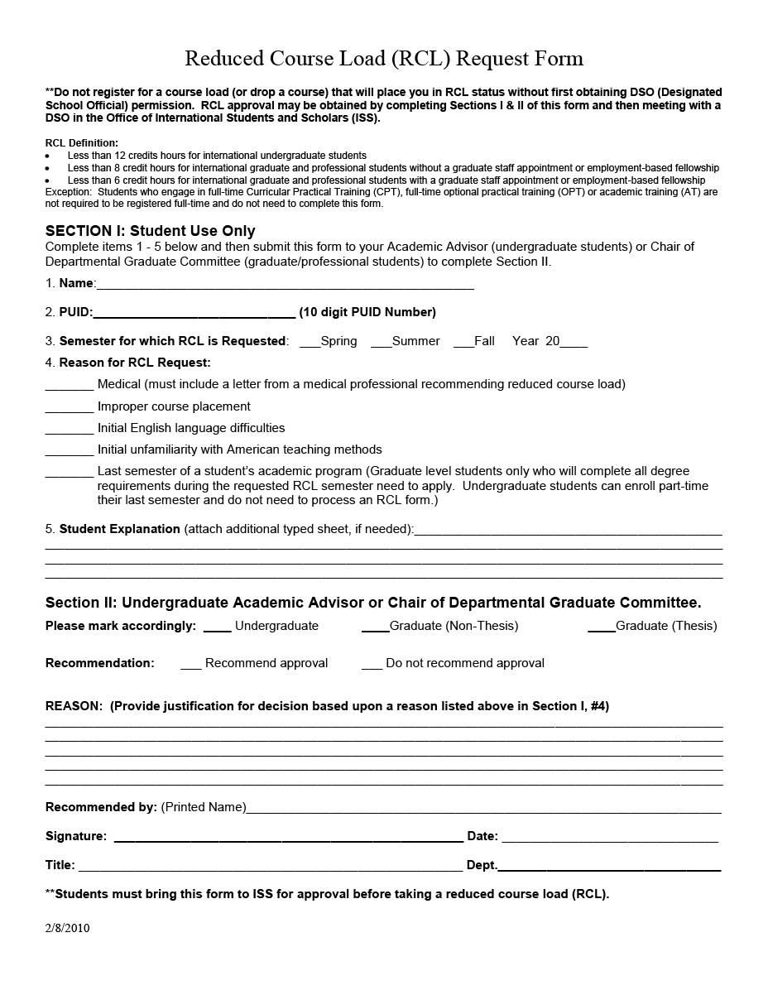

APPENDIX B:

SAMPLE PLAN OF STUDY
(available via the Electronic Plan of Study Generator on myPurdue)

Graduate Plan of Study
Status | APPROVED | Submitted 05/18/2005
Student | DOE, JOHN A. | 123456789
Student Email | doej@tech.purdue.edu
Department | AVIATION TECHNOLOGY | AVTH
Degree Title | MASTER OF SCIENCE : THESIS | MS
Program | Aviation & Aerospace Mgt -MS | AAM-MS
Date degree expected | AUG 2005
Concentration
Research Area | Safety Systems Management
Supplemental Notes: Add A Supplemental Note View All Notes
Subject | Type | Author | Date Added
 | PUBLIC |  | 06/08/2005
 | PUBLIC |  | 09/19/2005
Items in purple are completed. / Items in green are incomplete.
Courses: ** Grades posted here are as of the end of the semester that they were taken.
Late grade changes or title changes may not be reflected. If you see a discrepancy, contact the Graduate School.
Area | Courses Title | Subj.  Abbr. | Course  No. | Credit  Hours | Regis.  Type | Grade | B or  better | Transfer  From | Date Completed  To Be Completed
PRIMARY | MEASUREMENT/EVALUATION IN INDUSTRY | IT | 50700 | 3 | RE |  | - | - | May 2004
PRIMARY | QUAL & PROD IND & TECH | AT | 50800 | 3 | RE |  | - | - | Dec 2005
PRIMARY | MANAG RISK OF ORG ACCI | AT | 57300 | 3 | RE |  | - | - | Dec 2004
PRIMARY | AVIATION SAFETY SYSTEMS | AT | 57500 | 3 | RE |  | - | - | Aug 2005
PRIMARY | CRITICAL SYSTEMS THINKING | AT | 55000 | 3 | RE |  | - | - | Dec 2004
PRIMARY | ANLYS OF RES IN INDUSTRY AND TECH | TECH | 64600 | 3 | RE |  | - | - | May 2004
RELATED | HUMAN ERROR | AT | 57200 | 3 | RE |  | - | - | Dec 2003
RELATED | BIOMETRICS TECH&APPLIC | IT | 58100 | 3 | RE |  | - | - | May 2004
RELATED | CONC OF AV HUMAN FACTORS | AT | 57400 | 3 | RE |  | - | - | Dec 2003

Purdue graduate course tallies:
Purdue POS GPA: 3.80
Purdue Primary Area Credit Hours : 18
Purdue Related Area Credit Hours : 9
Purdue Area Not Specified Credit Hours: 0

Language Requirement: None
Comments Regarding Exceptions or Requirements: None
Advisory Committee Information and Approval Status
Level | Names of Advisory Committee Members | Cert | Faculty  Identifier | Status | Department  Code | Advisor in Area of
50 | ROBERT M. JONES (CHAIR) | R | C9999 | APPROVED by Robert M. Jones 10/09/2005 15:58:08 | T37 | SAFETY SYSTEMS
50 | LARRY W. SMITH | R | C8888 | APPROVED by Larry W. Smith 10/09/2005 16:01:49 | T37 | HUMAN FACTORS
50 | MANDY S. BROWN | R | C7777 | APPROVED by Mandy S. Brown 10/09/2005 13:25:00 | T37 | BIOMETRIC
Additional Authorization
Level | Authorization | Required Signature | Status
70 | Student | John Doe | SUBMITTED 09/18/2005 11:59:41
60 | Plan of Study Coordinator | Debbie Hulsey | APPROVED by Debbie Hulsey 10/09/2005 11:26:39
20 | Graduate Program Authorization | Gary Bertoline | APPROVED by Gary Bertoline 10/20/2005 14:17:14
10 | Graduate School Authorization | Patricia A. Springer | APPROVED by Patricia A. Springer 10/26/2005 09:20:50
0 | Processor | Richard D. Coffman | PROCESSED by Richard D. Coffman 10/27/2005 12:59:18

APPENDIX C:

FLOWCHART OF EPOS PROCESS
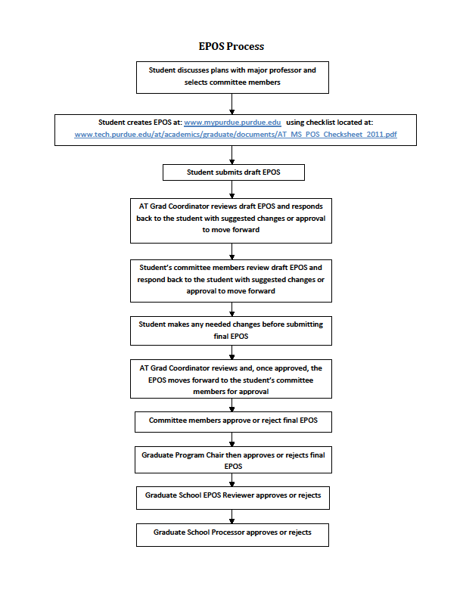

APPENDIX D (AT Form 1):

AT Form 1: Independent Study Request Form and Instructions
(available at http://www.tech.purdue.edu/Graduate/)

AT Form 1 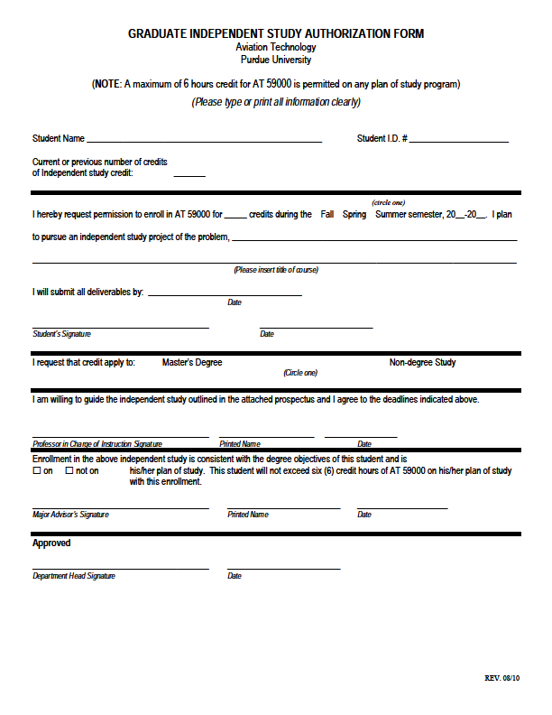

APPENDIX E:

Example Form 23

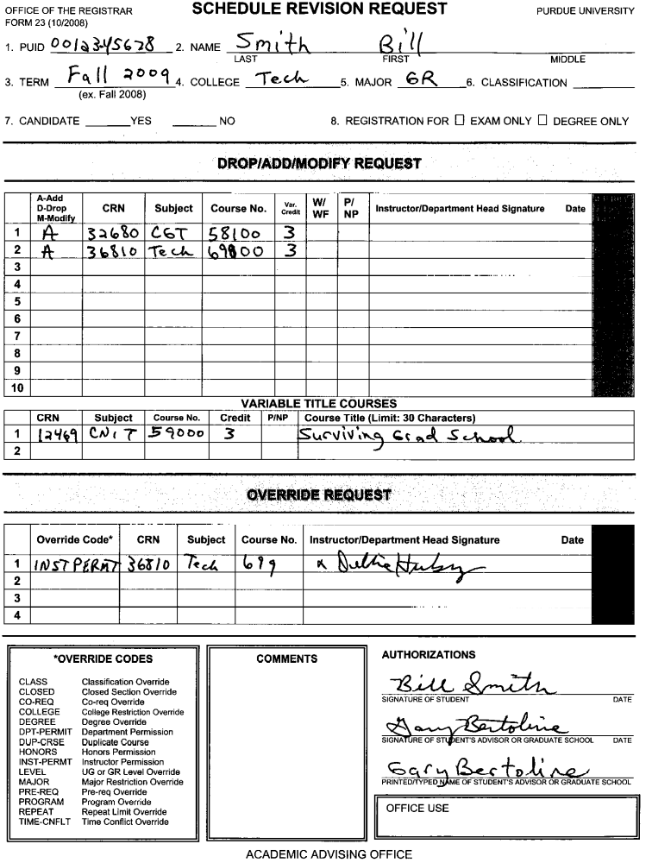

APPENDIX F:

aT Form 2: Acceptance of ThESIS proposal

(available at http://www.tech.purdue.edu/Graduate/forms_documents.cfm)

AT Grad Form 2 Please type or print clearly
V.1.0 July 2013

College of Technology
Graduate Studies

Acceptance MS Thesis Proposal
(To Be Submitted to AT Graduate Studies Office Following Proposal Defense Meeting)

Title of Project:

___________________________________________________________________

Proposal Defense Date: Project Type: Thesis
Dissertation
___________________________

___________________________ __________________________________
Chair Date (Month/Day/Year)

___________________________ __________________________________
Committee Member Date (Month/Day/Year)

___________________________ __________________________________
Committee Member Date (Month/Day/Year)

___________________________ __________________________________
Committee Member Date (Month/Day/Year)

___________________________ __________________________________
Signature of Candidate Date (Month/Day/Year)

___________________________
Printed Name of Candidate

APPENDIX G:

THESIS COVER PAGE

(available at http://www.gradschool.purdue.edu/thesis2.cfm)

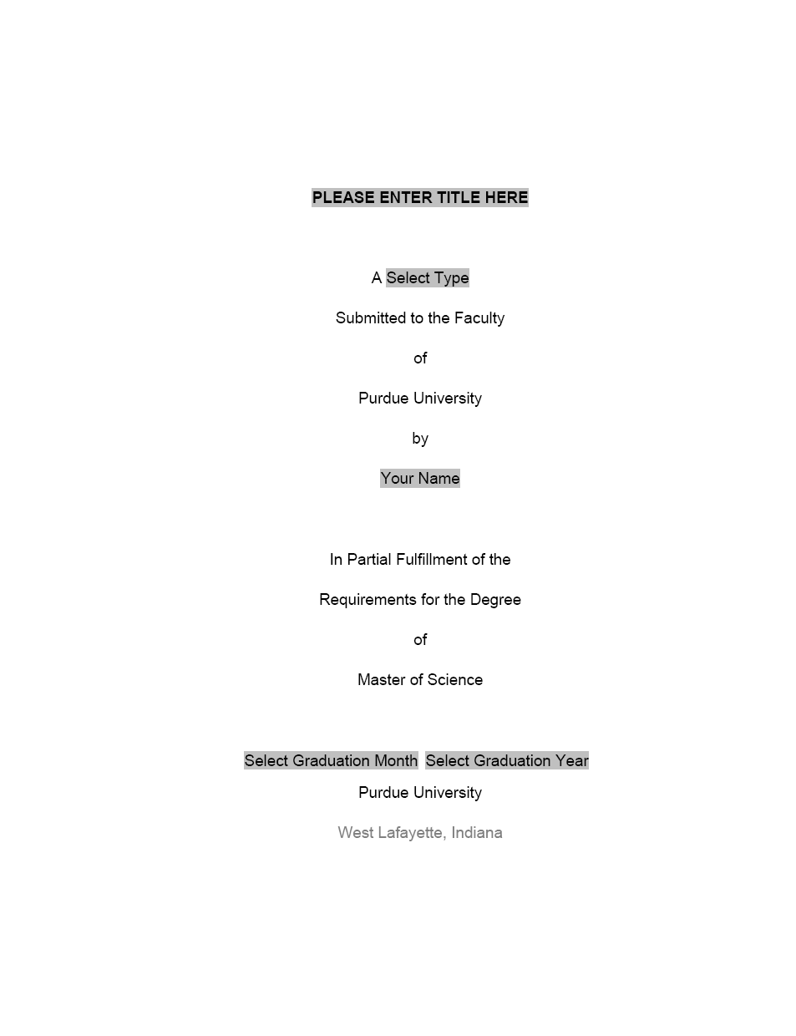

APPENDIX H:

CHECK YOURSELF REQUEST FORM

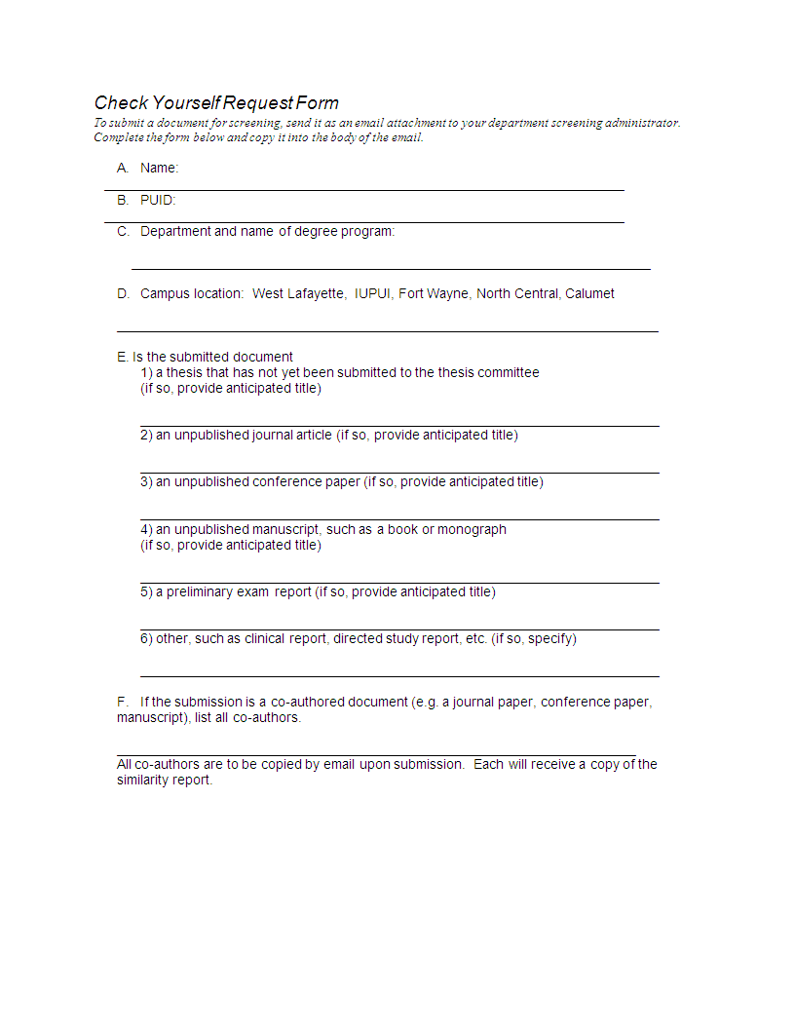

APPENDIX I:

GS Form 8: Request for appointment of examining committee

(more information available at http://www.gradschool.purdue.edu/faculty/forms.cfm)

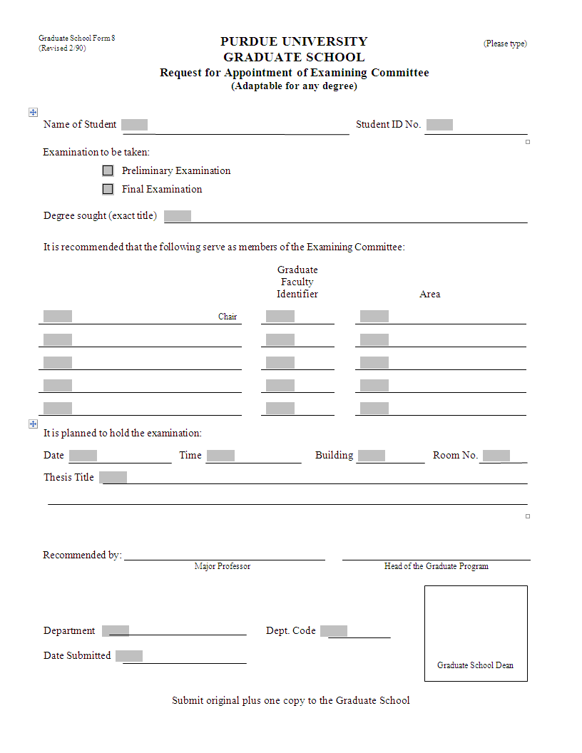

APPENDIX J:

GS Form 7: Report of master’s examining committee

(more information available at http://www.tech.purdue.edu/Graduate/grad_downloads/Form8.doc)

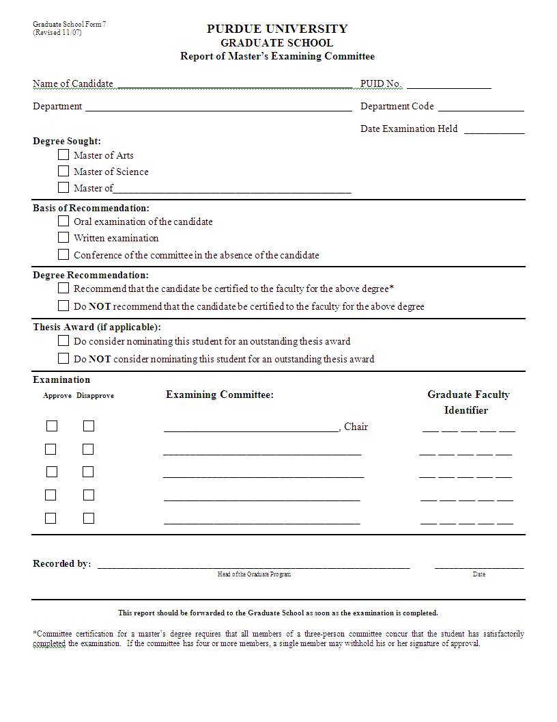

APPENDIX K:

GS Form 9: Thesis acceptance

(more information available at http://www.gradschool.purdue.edu/thesis3.cfm)

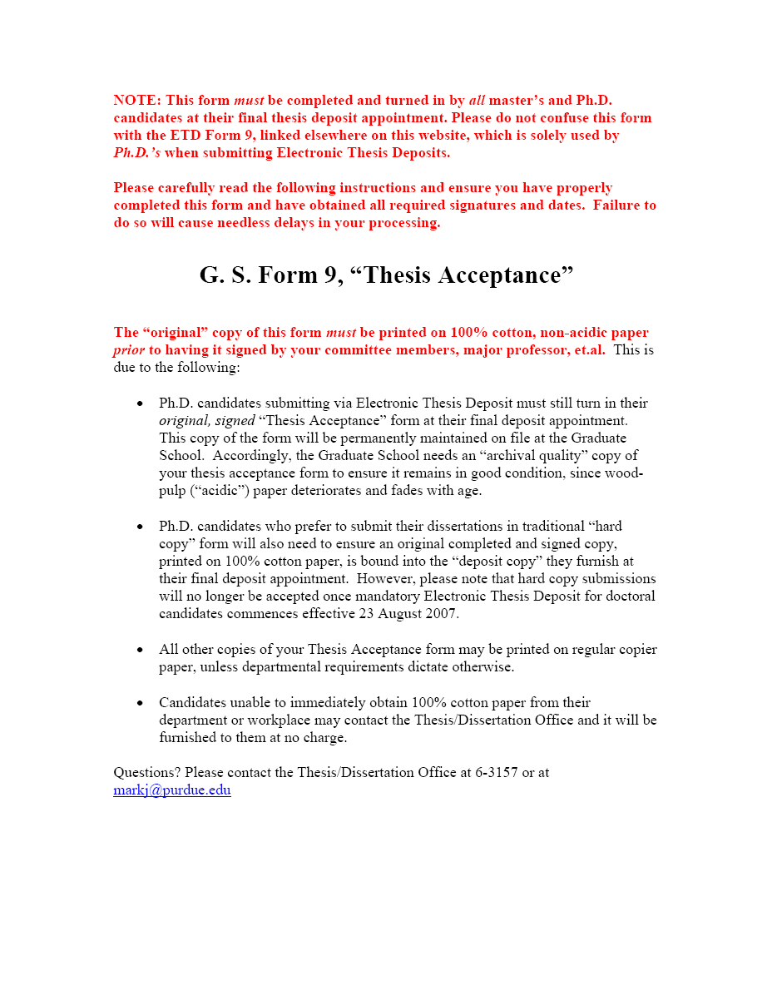

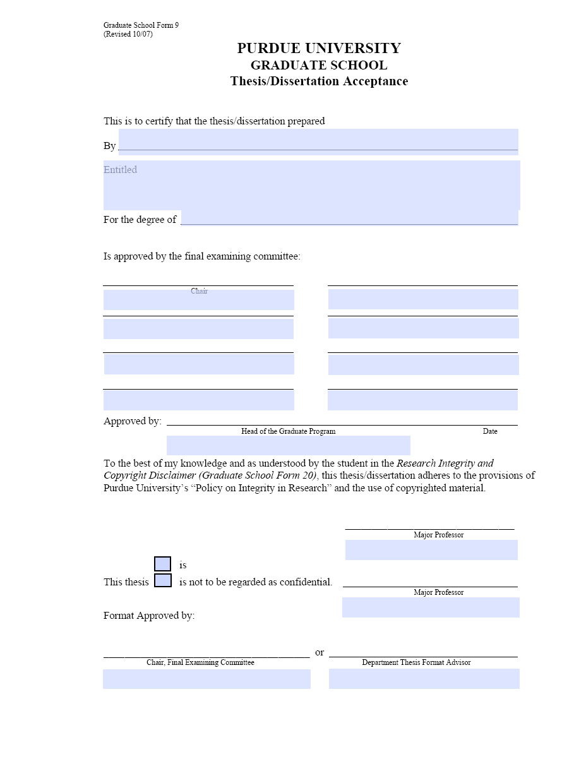

APPENDIX L:

GS ETD Form 30: Electronic thesis deposit

(more information available at http://www.gradschool.purdue.edu/thesis3.cfm)

INSTRUCTION PAGE FOR
GS FORM 30
FOR ELECTRONIC THESIS DEPOSIT
(Formerly called ETD Form 9)

INCLUDE GS FORM 30 BEFORE THE FIRST PAGE OF YOUR ELECTRONIC THESIS DOCUMENT
DO NOT INCLUDE ANY OTHER FORMS WITH YOUR ELECTRONIC THESIS SUBMISSION
DO NOT INCLUDE THIS INSTRUCTION PAGE WHEN YOU ATTACH TO THESIS DO NOT ATTACH ANY OTHER FORMS TO YOUR THESIS

Please use ADOBE ACROBAT PRO to complete this form
A free 30-day trial is available here: https://www.acrobat.com/free-trial-download.html
Updated 08/2014

• TO COMPLETE GS FORM 30:
1. Type your name as it appears in your Purdue Records in the first field
2. Type your thesis title using either ALL CAPS or Title Case in the second field
3. Select your Degree from the pull down menu
4. Type the names of your committee members, major professor, and head of the departmental graduate program as they appear on your signed GS Form 9 (include the date the head of the departmental graduate program signed your GS Form 9)

• TO CONVERT GS FORM 30 TO A NON-INTERACTIVE (STABILIZED) FILE:
OPTION 1

1. After you complete the form, print it
2. Scan the print out as a PDF
OPTION 2*

1. Click File and choose Print
2. Select “Adobe PDF” from printer selection using drop down menu.
3. Specify print range as the last page (form page) only. This will keep you from including the instruction page.
*For MAC users: Using the Create button, save GS Form 30 as a Word document, then using the print command in Word choose Print as PDF.

• TO COMBINE PDF FILES
(to include GS Form 30 as the first page of your electronic thesis submission):
1. Open your PDF thesis.
2. Click on Tools in the right side of the Ribbon.
3. Under Insert Pages click Insert From File.
4. Select your non-interactive PDF ETD Form 9 and click Okay.
5. Set the location to Before and check the button next to First Page, then click Okay.
6. Save your new, combined document.

Questions?
Email gradhelp@purdue.edu with THESIS FORMS in the subject line
Or call (765) 494-3231

THESIS/DISSERTATION OFFICE | THE PURDUE GRADUATE SCHOOL
Young Hall B-80 |155 S. Grant Street |West Lafayette, IN 47907

Graduate School Form
(Revised / )

PURDUE UNIVERSITY GRADUATE SCHOOL Thesis/Dissertation Acceptance

This is to certify that the thesis/dissertation prepared

By
Entitled

For the degree of

Is approved by the final examining committee:

To the best of my knowledge and as understood by the student in the Thesis/Dissertation Agreement, Publication Delay, and Certification/Disclaimer (Graduate School Form 32), this thesis/dissertation adheres to the provisions of Purdue University’s “Policy on Integrity in Research” and the use of
copyrighted material.

Approved by Major Professor(s):

Approved by:

Head of the Graduate Program Date

APPENDIX M:

GS Form 32: Masters thesis agreement

(more information available at http://www.gradschool.purdue.edu/thesis3.cfm)

INSTRUCTION PAGE FOR
GS FORM 32

DO NOT INCLUDE GS FORM 32 WITH YOUR ELECTRONIC THESIS SUBMISSION ALL SIGNATURES MUST BE IN INK—NOT PENCIL
Updated 2014

• iThenticate Plagiarism Screening by your major professor must take place prior to completing this form
• Major professors can obtain iThenticate accounts from Dr. Peter Dunn, Purdue’s Research Integrity Officer
• For information on iThenticate visit: purdue.edu/research/vpr/rschadmin/plagiarism/

HOW TO COMPLETE GS FORM 32
1. Have your major professor review your thesis/dissertation using iThenticate

2. Complete page 1 by typing your name, PUID, major professor’s name, and thesis title, and by selecting your degree, department, and campus from the drop down menus
(works best in Adobe Acrobat Pro—free trial available acrobat.com/free-trial-download.html)

3. Print the form (do not include this instruction page if printing double sided) and complete your portion of pages 2, 3 and 4

4. Have your major professor write the date of your iThenticate review on page 4

5. Have your major professor sign page 4

6. If you are requesting a delay of publication: Have your major professor sign page 3

7. Bring the completed form to your deposit appointment

SPECIAL INSTRUCTIONS FOR LONG DISTANCE DEPOSITORS
Please make every effort to have your major professor perform the iThenticate review and sign this form before you leave the
Lafayette area. If this is not possible:

1. Have your major professor review your thesis/dissertation using iThenticate

2. Have your major professor print this form, and sign and date page 4

3. If you are requesting a delay of publication: Have your major professor sign page 3

4. Have your major professor send page 4 (and, if requesting a delay, page 3) to the Thesis/Dissertation Office (Young Hall Room B-
80) with an attached note stating your full name, department and degree*

5. Complete page 1 by typing your name, PUID, major professor’s name, and thesis title, and by selecting your degree, department, and campus from the drop down menus
(works best in Adobe Acrobat Pro—free trial available acrobat.com/free-trial-download.html)

6. Print the form (do not include this instruction page if printing double sided) and complete your portion of pages 2, 3 and 4

7. Mail the form to: Thesis/Dissertation Office
B-80 Ernest C. Young Hall
155 S. Grant Street
West Lafayette, IN 47907-2114
*All your forms must be in the T/D Office before your appointment time or your appointment will be cancelled. Make sure your major professor understands this and knows when you are depositing.

Questions? Email gradhelp@purdue.edu with THESIS FORMS in the subject line or call (765) 494-3231

THESIS/DISSERTATION OFFICE | THE PURDUE GRADUATE SCHOOL
Young Hall B-80 |155 S. Grant Street |West Lafayette, IN 47907

PURDUE UNIVERSITY GRADUATE SCHOOL

Thesis/Dissertation Agreement, Publication Delay, and Research Integrity & Copyright Disclaimer

Author PUID Degree Department Campus
Major Professor

Thesis/Dissertation Title

The following items apply to all authors and must be fully completed/signed:

• I. Master’s Thesis/Ph.D. Dissertation Agreement

• II. Delay of Publication

• III. Research Integrity & Copyright Disclaimer
I. Master’s Thesis/Ph.D. Dissertation Agreement

Purdue University maintains digital copies of theses and dissertations produced by Purdue University students in the Purdue Institutional Repository, Purdue e-Pubs. In the interest of promoting learning and discovery, Purdue University permits access to these archives.

Purdue University requests that authors of theses and dissertations grant to the University the right to copy, distribute, and make these available through such digital outlets as the Purdue University Institutional Repository. Such permission allows the author and the University to contribute to the advancement of knowledge and research by making their works available to scholars. Research becomes more broadly disseminated and may assist authors in future endeavors. Purdue University typically receives no monetary gain from the reproduction and distribution of master’s theses and Ph.D. dissertations except for recovering costs associated with such reproduction and distribution (e.g., without authors’ permission, master’s theses generally cannot be copied, in whole or in part, for such educational purposes as inter-library loan.)

Copyright ownership remains with the author in accordance with Purdue University Intellectual Policy I.A.1. This agreement does not prohibit the author in any way from entering into a publishing contract. The author retains all the exclusive rights granted to copyright holders under United States copyright law subject only to the rights granted to the University as stated below.

Agreement

I grant in perpetuity, without restriction, royalty free to Purdue University the nonexclusive right and license to reproduce, distribute, and display, in whole or in part, my master’s thesis or Ph.D. dissertation in any format now known or later developed (e.g., ePubs) for preservation and access in accordance with this agreement. This agreement does not represent a transfer of copyright to Purdue University.

I understand that the University will observe any publication restrictions that I have placed on my work and will not make my thesis or dissertation available to other parties until such time as it has been released from these restrictions or I have given my prior permission to the University to allow access by others.

I represent and warrant to Purdue University that the Work is my original work and does not, to the best of my knowledge, infringe or violate any rights of others nor does the deposit violate any applicable laws. I further represent and warrant that I have the authority and/or have obtained all necessary rights to permit Purdue University to use, duplicate, and distribute, the Work and that any third-party owned content is clearly identified and acknowledged within the Work.

This agreement shall survive assignment of any and all exclusive rights provided to copyright holders in Section 106 of the United States copyright law.

Signature of Author Date (mm/dd/yyyy)

II. Delay of Publication

Authors may request a publication restriction as part of the ETD submission process. While such restrictions are not generally recommended by the Graduate School, there are cases where their use may be prudent (e.g., patent applications, proprietary data, article and monograph publishing, etc.).

Careful consideration should be given before deciding. Delaying publication will prevent copies of your dissertation from being made available to others outside of the University who wish to read about your research in a timely fashion.

If you are considering a delay of publication, discuss the matter with your major professor. If you opt for a delay, your major professor must indicate his/her concurrence by signing on the appropriate line below.

Your delay of publication will commence upon receipt of your ETD by ProQuest Information & Learning and carry over to the Purdue University institutional repository. During your delay period, your abstract and citation information will be available for viewing online. However, your thesis/dissertation will be withheld from viewing and/or purchase by outside parties. Once your delay has expired, ProQuest will then post your document online expeditiously.

Please note that Delay of Publication is not the same as Confidentiality. Delays of Publication are offered via ProQuest Information & Learning (your nominal publisher), but Confidentiality is a program administered by the Purdue University Graduate School. Confidentiality requires GS Form 15. You may use delays and confidentiality separately or in tandem.

Delay

The delay information on this form must match the delay information you provide to ProQuest.

No publication delay

Publication delay until (mm/dd/yyyy)

Signature of Author Date (mm/dd/yyyy)

Signature of Major Professor* Date (mm/dd/yyyy)

* Major professor’s signature is only required RQ WKLV SDJH when a delay is requested

III. Research Integrity & Copyright Disclaimer

I certify that in the preparation of this thesis/dissertation, I have observed the provisions of Purdue University Policy
III.A.2, November 18, 2011, Policy on Research Misconduct.*

I certify that all copyrighted material incorporated into this thesis/dissertation complies with United States copyright law and that I have received written permission from the copyright owners for my use of their work, which is beyond the scope of the law. I agree to indemnify and save harmless Purdue University from any and all claims that may be asserted or that may arise from any copyright violation.

Signature of Author Date (mm/dd/yyyy)

I certify that the author’s manuscript was diagnostically reviewed by iThenticate on the date indicated below. Based on the results of the iThenticate diagnostic review; and, to the best of my knowledge, the manuscript includes original work of the author and, in good faith, I believe all content from other authors appearing in the thesis/dissertation has been properly quoted and attributed.

Date of iThenticate Review

Signature of Major Professor Date (mm/dd/yyyy)

* http://www.purdue.edu/policies/ethics/iiia2.html

APPENDIX N:

GS Form 15: REQUEST FOR CONFIDENTIALITY

(more information available at http://www.gradschool.purdue.edu/thesis3.cfm)



