On the BoilerConnect screen, select

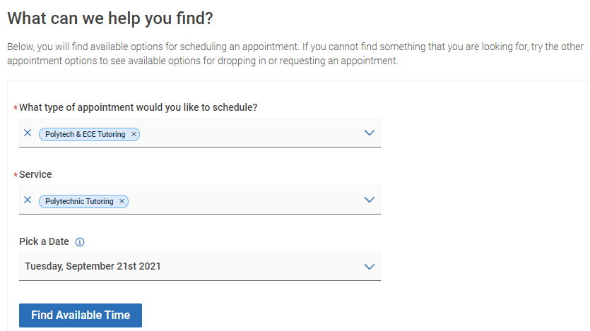

Once you do that, you're prompted to choose a class. This list is based on what courses the student is enrolled in and what tutors have availability for.

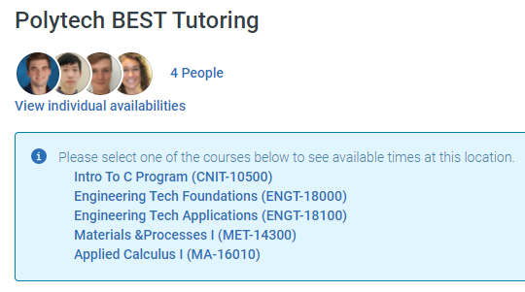

In this case I chose ENGT-18000, and now my option is to just choose a time or choose a person and then see only their times.

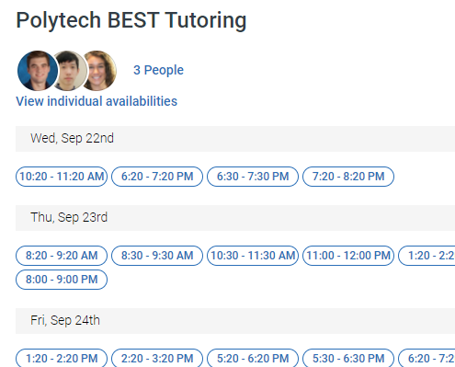

(It goes on much farther out into the future than this...)

Before I pick a time, I could also go back over to the left hand side and choose a staff member or indicate whether I want virtual vs in-person. If I make any choices there, it will limit the times that show up on the right side.

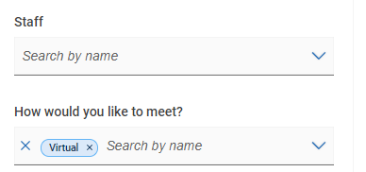

Once I pick a time, I get to review appointment details, see the URL/phone number or campus location (depending on virtual vs in-person), and confirm the appointment.

