tITLE OF THESIS
by
Your Name

A Choose Thesis Type
Submitted to the Faculty of Purdue University
In Partial Fulfillment of the Requirements for the degree of

Choose Degree
Department of Computer and Information Technology
Choose Campus Location, Indiana
Choose Graduation Term

THE PURDUE UNIVERSITY GRADUATE SCHOOL
STATEMENT OF CHOOSE THESIS TYPE APPROVAL
Dr. John Doe, Chair
Department of Aeronautics and Astronautics
Dr. Jane Doe
Department of Aeronautics and Astronautics
Dr. Jim Doe
Department of Aeronautics and Astronautics
Add or Delete Committee Member
Add or Delete Department
Add or Delete Committee Member
Add or Delete Department

Approved by:
Jeffrey L. Whitten
Head of the Departmental Graduate Program

Replace this paragraph with your brief dedication. Else delete page.

ACKNOWLEDGMENTS
This page is optional.

To copy & paste your work on this page, please highlight this text and replace it.

If you are not including acknowledgements, delete this page.

If you are acknowledging only one person, change the title to ACKNOWLEDGMENT.
TABLE OF CONTENTS
LIST OF TABLES vii
LIST OF FIGURES viii
LIST OF ABBREVIATIONS ix
GLOSSARY x
ABSTRACT xi
CHAPTER 2. INTRODUCTION 1
2.1 The Basics 1
2.2 Margins 1
2.3 Heading Styles 1
2.3.1 Major Headings 2
2.3.2 Chapter Headings 2
2.3.3 Subheading 1 2
2.3.4 Subheading 2 2
2.3.5 Subheading 3 2
2.3.6 Subheading 4 3
2.4 Inserting a Table of Contents 3
2.5 Notes 3
2.6 Page Numbers 4
2.7 Issues with Pagination 4
CHAPTER 3. TIPS 5
3.1 Before You Submit 5
3.2 Inserting Internal Links (Bookmarks) 5
3.3 Sample Pages and Formatting Checklist 5
3.4 Landscape Page 13
CHAPTER 4. DUAL COLUMNS 14
APPENDIX A. SURVEYS 15
APPENDIX B. FORMS 16
REFERENCES 17
VITA 18
PUBLICATIONS 19

LIST OF TABLES
Table 2.1 Suggested Line Spacing 7
Table 2.2 Oversized Table 9

In order to generate a List of Tables easily, you will need to assign a caption to all of the tables in your document. After this has happened, click on the References Ribbon, select Insert Table of Figures, under general select Table from drop down box, select OK.

If you use landscape pages, make sure the landscape page numbers match what is listed in your List of Tables.

LIST OF FIGURES
Figure 2.1 Styles Box 8
Figure 2.2 Purdue Fountains 11
Figure 2.3 Oversized Figures 13
Figure 2.4 Snowy Hovde Hall 14

In order to generate a List of Figures easily, you will need to assign a caption to all of the tables in your document. After this has happened, click on the References Ribbon, select Insert Table of Figures, under general select Figures from drop down box, select OK.

If you use landscape pages, make sure the landscape page numbers match what is listed in your List of Figures.

LIST OF ABBREVIATIONS
THIS SECTION IS REQUIRED IN ALL CIT THESES.

Entries should be alphabetized and double-spaced (or 1.5 spacing). Each entry should include the acronym, and then the spelled out version. No definitions are provided in this section. The following are sample entries:
ACM – Association for Computing Machinery
AD – Architectural Description
COTS – Commercial Off-the-Shelf
IoT – Internet of Things
IT – Information Technology
OCM – Organizational Change Management
ROI – Return on Investment

If definitions are also required, create those entries in the GLOSSARY section of the front matter.

GLOSSARY
THIS SECTION IS REQUIRED IN ALL CIT THESES.

In TECH 64600, this section may have been written in Chapter 1 of your proposal. For CIT theses, these definitions should be moved to this section and formatted as described below.

Entries should be alphabetized. The first line of each entry should be reverse indented. The entries must be double-spaced. There must be one blank (empty) line between each entry. The following are sample entries:
Association for Computing Machinery – An international scholarly computing society that develops and maintains model curricula for computer science, information technology, and information systems programs, and that publishes scholarly research in those fields.

Internet of Things – an extension of the internet wherein physical devices, vehicles, buildings and other physical items—embedded with electronics, software, sensors, actuators, and network connectivity—are enabled to collect and exchange data and provide services.

ABSTRACT
Author: LastName, FirstName, MiddleInitial. Choose Degree
Institution: Purdue University
Degree Received: Choose Graduation Term
Title: (Type Your Thesis Capitalizing the First Letter of Major Words: Do Not Use All Caps). Be sure to indent subsequent lines of your title.
Major Professor: FirstName LastName.

REQUIRED SECTION

Two different kinds of paragraph spacing will be used on this page. The first three lines, where your personal information is included, make up the introduction block or introduction paragraph. Use only single space and set Before/After space setting to zero (in Paragraph setting box).

In the main body of the abstract, use the same spacing you use throughout the rest of your document (either double spacing or 1.5 line spacing).

To copy & paste your work here, please highlight the paragraphs to replace the text.

Keep the section break below to allow Chapter 1 to start page 1.

INTRODUCTION

The Basics
This template is best used with MS Office 2013 on a PC or MS Word 2016 on a Mac. It is suggested to turn on the Show/Hide tool (¶) that can be found on the Home ribbon so you can track you spacing and section breaks.

Review the Template Guide before you begin. Use it for troubleshooting. If you can’t find a solution there, try Microsoft’s extensive help pages:
http://office.microsoft.com/en-us/word-help/word-help-and-how-to-FX101818070.aspx

Margins
Margin requirements are 1.5” left margins and 1” bottom, right, and top margins. 1.5” left margin is recommended by Boiler Copy Maker for screw & post bindings – if you wish to have a hard bound copy made. Hard bound copies are not required for submission to the Graduate School, we will work solely with the PDF copy you upload to ProQuest.

Heading Styles
There are many heading styles that have been added to the Styles Ribbon. There are Purdue Headings 1-6 above. You will have to manually change the text back to normal style after you apply the heading. You will want to use these styles so you can generate a table of contents without any issues. If you open the navigation toolbar [Ctrl + F] and under the search document bar you choose “Headings” you will be able to easily track which headings will go in your table of contents.

If after you apply a Style to a heading and you receive Error! Bookmark not defined in your Table of Contents after updating the page number, go back to your heading that is causing the issue and make sure there is still a style applied to it. You can update the entire table to resolve the issue – if you had previously formatted the Table of Contents, you may have to re-format.

Major Headings
This heading will be your Major heading style without chapter numbers. It will be bolded and centered on page. You will not want to use this heading for any title before and including the table of contents, however you will include all front matter and back matter sections under this heading style. Example:
ABSTRACT

Chapter Headings
This heading will be your normal Chapter heading. It will be bolded, numbered, centered on page, you will not want to use this heading for any title before chapter one or after your summary/conclusion chapter. This heading is formatted for 3 single spaces after the heading and before the text – do not reformat this as it is a University requirement. Example starts on next page:

CHAPTER 1. INTRODUCTION

Subheading 1
This heading will be a secondary heading. It will centered on page, underlined, but will not be typed in all caps. Example:
1.1 Introduction

Subheading 2
This heading is a level 3 heading. It will be centered on page. Example:
    - Introduction

Subheading 3
This heading is a level 4 heading - it aligns with the left margin and is underlined. Example:
      - Introduction

Subheading 4
This is a level 5 heading – it aligns with the left margin.

Inserting a Table of Contents
In order to insert an automatic table of contents, you will have needed to apply styles to your headings (as shown above). Once your headings have been assigned a style, you can then insert a table of contents that will automatically populate with the correct heading level indentations, leader dots, and page numbers. This will also create an embedded link from your table of contents to the section in your thesis in both a MS Word doc and in a PDF file.

To insert the table, follow these instructions:
- In Ribbon above, click References
- Click ‘Table of Contents’ on the left hand side of the ribbon
- Choose ‘Custom Table of Contents’ below the built-in tables
- After a Table of Contents box pops up, click “OK”, without making any changes within the box

Typically, inserting a table of contents, list of figures, and list of figures should be the last step in the formatting practice. If you’ve made changes to content that moves a heading to a different page number, all you’ll need to do is go back to your inserted table of contents, right click, select ‘Update Field’, and select “Update page numbers only”. This will make changes to your page numbers and won’t affect the headings.

Notes
If you are planning to include List of Figures and List of Tables, we recommend you using the following method to insert your captions:
- In Ribbon above, click References
- In Captions section, click on Insert Caption
- Next to Label, chose Table or Figure
- Click OK
- Type your caption next to the table/figure number

To create a table of contents you will need to assign a heading style to each heading in your entire document then follow the steps below:
- Locate your Table of Contents page above
- In the Ribbon above, click References
- In the Table of Contents section, click Table of Contents
- Look past the built-in Table of Contents and select Insert Table of Contents
- Under the General section in the Show Levels box, select the number of headings you want to show in the Table of contents – 3 levels are common, but it can incorporate all levels, if you wish.

Page Numbers
Page numbers will go in the upper right hand corner of each portrait page. If you are using any landscape orientation pages, the page number will go in the lower right hand corner with vertical text (see page 11 for example). Page number font and font size needs to be the same as the main body text.
Roman numeral pagination will occur between dedication and abstract pages while Arabic numeral pagination will occur between chapter 1 and the end of the document.

Issues with Pagination
Occasionally, page numbers will overlap due to section breaks. To fix this issue, simply click on the page number and locate the Design ribbon at the top of the page. Click the drop down arrow on page number > Format page numbers > under the Page numbering section choose Continue from previous section.

TIPS

Before You Submit
Before you convert to PDF, carefully review our Sample Thesis Pages and our Formatting Checklist, and then double check the formatting of your entire document, page by page.

Inserting Internal Links (Bookmarks)
If you would like to click on a title in the Table of Contents and it take you straight to that page (or figures/tables/equations), follow the steps below: (click on Publications in TOC for example)
- In the table you’ve created, highlight the text you want to link
- Click the Insert Ribbon
- Click Bookmarks
- Click on or create the appropriate bookmark in the list and click OK
- Click OK again and your bookmark will be created.
You can use this option to create external hyperlinks as well using the Hyperlink option in the Insert Ribbon (Sample Thesis Pages above is an example of an external hyperlink).

Sample Pages and Formatting Checklist
The sample pages and Formatting Checklist are available on our website:
http://www.purdue.edu/gradschool/research/thesis/index.html

If only one table (or figure) is desired on one page, center the table (or figure) on the page.

Table 2.1 Suggested Line Spacing
After Space Setting | Where to Use It
12 (equal to single line spacing) | After lowest level subheadings
18 (equal to1.5 line spacing) | After higher level subheadings
24 (equal to double spacing) | After figure captions or table captions
36 (equal to 3 single spaced blank lines; equal to 1 inch) | After title page blocks, major headings and chapter headings

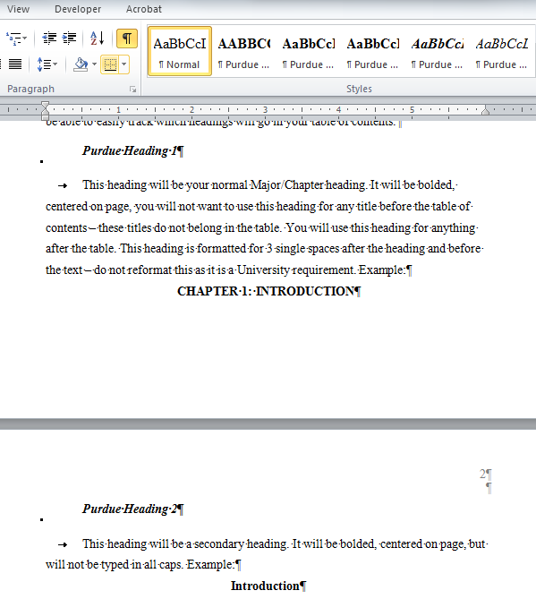
Do not work on TABLE OF CONTENTS, LIST OF FIGURES, or LIST OF TABLES until you finish the last page of your thesis and pagination.
Figure 2.1 Styles Box

Table 2.2 Oversized Table
Table 2.2 continued

In order to add the table continuation above the table, you’ll need to split the table. You can achieve this by selecting the table, choose Layout ribbon, find the Merge section, and click Split Table. You will want to place the cursor on the line that you’d like to move to the next page before selecting Split Table.

OR

Add a new row above the table and merge the cells to form one cell above the table so you can type the continuation. This row should not have any borders outside of a bottom border to begin the continuation of the table.

Do you have a figure that goes on for 2 or more pages?
Add the caption to the first page and add Figure …. Continued above the figure on the next pages.
Example:
A)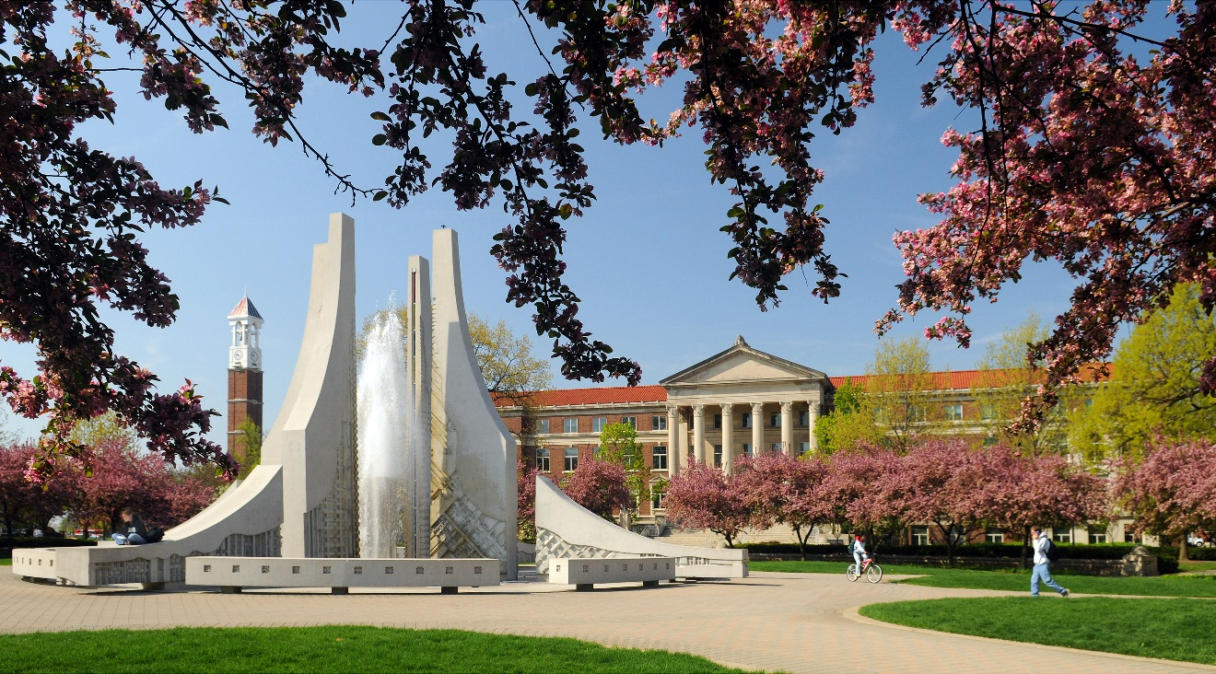
B)
Figure 2.2 Purdue Fountains
Figure 2.2 continued
C) 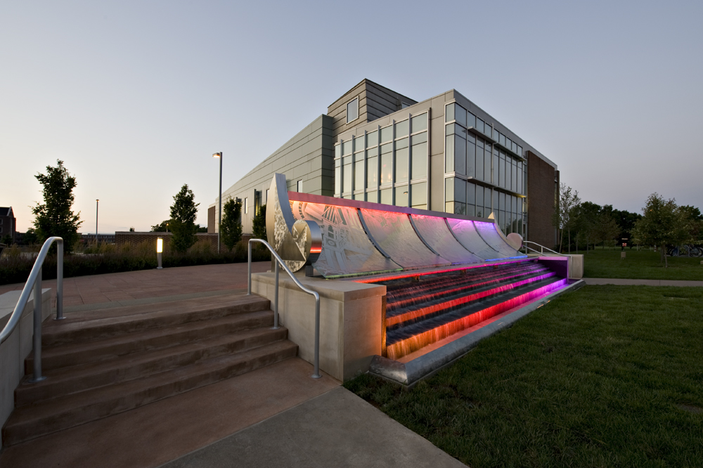

Do you have a figure or a table that is too large to add a caption to the same page as the figure or table?
Add the caption to the page before the figure or table. The caption should be centered on the page vertically.
Example:
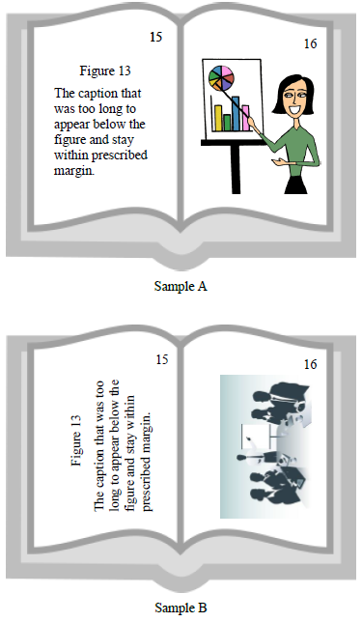
Figure 2.3 Oversized Figures

Landscape Page
You may use landscaped pages for large tables or figures that normally will not fit within left and right margins. Note that page numbers will need to be added manually with a text box (that is in place in the bottom right hand corner). A normal page number will show up in the upper right hand corner when adding pagination. You will need to unlink this page and the next page’s pagination to previous in order to keep the pagination in the correct place.

The margin settings on these pages will be different: 1” left, bottom, and right and 1.5” top. The top margin will be different due to printing – the top margin is actually the left margin when you stand the page up.

To achieve adding a landscape page, you will need to add a Next Page section break on the previous page. You will also need to add a Next Page section break to the end of this page to convert back to a portriat orientation.

It is beneficial to open the Show/Hide control on the Home Ribbon in the Paragraph section so you can see where all extra spacing is and where section and page breaks are.

Captions may be no smaller than size 10 font. Make every effort to allow the text to stay on same page as figure or table; if needed, the text may overflow to the next page. Oversized pages (11x14 or 11x17) may be used to accommodate larger tables.

13
Figure 2.4 Snowy Hovde Hall

DUAL COLUMNS
If you want your thesis to look more like a journal article, dual columns are acceptable. You will need to contact your department to ensure this format style meets your departmental requirements.

Footnotes are also acceptable on these pages.

Please ensure that headings and pagination remain follow Purdue’s formatting requirements.

There is an automatic Continuous section break added to the end of the dual columns – do not delete this section break.
In order to make these dual columns look more like a professional journal article, it is permissible to leave the spacing set at the MS Word default of Multiple > 1.15 spacing.
Margin requirements will be the same as a single column – 1.5” left, 1” bottom, right, and 1” and 2” top.

APPENDIX A. SURVEYS
OPTIONAL SECTION

If you only have one appendix the title should read APPENDIX, do not include any other information in the title.

Use secondary headings for Appendix titles. You will need to manually type the heading in ALL CAPS, or you can highlight the text and use the Shift + F3 function and it will automatically change the text to ALL CAPS. These headings will be indented in your table of contents, but you will add APPENDICES to the table so they will be indented under a major heading. If you are only using one Appendix, list it as a level 1 heading and do not include APPENDICES in the table of contents.

APPENDIX B. FORMS
If you have large tables or figures to include we ask that you use landscape pages and place the Appendix Title above the figure/table.

REFERENCES
Include reference entries here using the style preferred by your department.
References may either be a separate section (like shown in this template) or they may be listed after each chapter. If references are placed at the end of the chapters, they will need to begin on a new page.

References and Appendix section can be switched as author desires.

Examples:

(APA style in Alphabetical order)
Applewood, John (2015, December 17). How to Format a Purdue Thesis. Retrieved from http://www.purdue.edu/gradschool/research/thesis/index.html
Brownstone, Daniel (2015, January 24). Sample Thesis Pages. Retrieved from http://www.purdue.edu/gradschool/research/thesis/index.html

-OR-

(APA style in Endnote referenced order)
[1] Brownstone, Daniel (2015, January 24). Sample Thesis Pages. Retrieved from http://www.purdue.edu/gradschool/research/thesis/index.html
[2] Applewood, John (2015, December 17). How to Format a Purdue Thesis. Retrieved from http://www.purdue.edu/gradschool/research/thesis/index.html

Follow your department’s style for your References section.

To copy & paste your work on this page, please highlight this text and replace it.

VITA
OPTIONAL SECTION – Usually not included in CIT masters theses. More common in Ph.D. dissertations.

We strongly recommend you not include any private data like your home address, email address, or phone number.

If you are unsure about what to include in your vita, consult with your department and/or major professor. The vita can be written as a narrative or in curriculum vita (CV) form. Please keep vita format identical to the format used in thesis (margins, spacing, and text font).

PUBLICATIONS
OPTIONAL SECTION

This is where you can include copies of your own published papers (or papers accepted for publication. You can include a PDF of a published article. This article may either be in color or black and white.

Steps to insert a PDF into a document without having to screenshot:
- Select Insert ribbon.
- Select Object in the Text section.
- Choose the first Adobe Acrobat Document.
- Locate your file and click Open.
- Your file will open, close the file – it will automatically show up in your document and fit within the required margins.
If you have questions or need any guidance inserting a PDF into your document, contact our office.

All pages of publications need page numbers sequential to the number in the rest of your thesis. You may need to block out original page numbers to prevent confusion. You may use the landscape text box and rotate it to fit in the upper right hand corner of the page. You will need to ensure the page number is horizontal when using the text box.

If you have only one publication, change the heading to PUBLICATION.

This is a footnote. Do not allow the footnote to be smaller than a font size of 10. Footnotes should not flow over to the next page; they should stay on the same page, whenever possible. You may adjust the page margin ONLY on footnote pages to accommodate lengthier footnotes.
This is another footnote.
This is another footnote. Try to keep the lines of the footnotes as even as possible. You may have to add a few spaces to the end to achieve the result.

