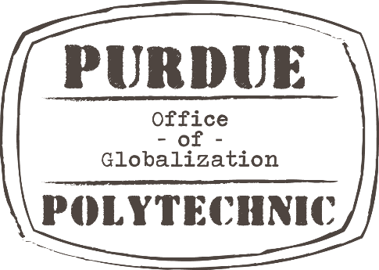
Explore the Global Classroom:
Bavaria to Bohemia

As a student admitted to a major in the Polytechnic Institute at Purdue University, you can jump start your global experiences and apply for a study abroad opportunity that takes place in Germany/Czech Republic before you start classes at Purdue in August.

Benefits:
- Eligible students may offset costs with a $500 - $1,500 Purdue Moves Scholarship.
- Meet other first-year students from a variety of majors at Purdue.
- Challenge yourself and your classmates while you experience a new country and culture.
- Start working toward three Purdue credits before even moving to campus.
- Explore Polytechnic partner institutions early in your academic career.
- Fulfill a global requirement.

This experience is offered through the Polytechnic’s strategic partnerships with Munich University of Applied Sciences in Munich, Germany and Czech Technical University in Prague, Czech Republic. This 3 credit hour course will utilize the Global Competence Certificate (GCC) curriculum as we work toward increasing the intercultural competence of our Polytechnic student participants. Students will complete course work using the GCC online modules as well as focusing on the benefits of intercultural competence in the tech fields that operate in a global setting. Find out more about the program requirements, activities, learning objectives and detailed itinerary.
https://www.studyabroad.purdue.edu/programs/flyer.cfm?flyer=1454

We are excited to help you go global as part of your academic experience at Purdue.

Email program leader, Elizabeth Barajas, for more information: barajase@purdue.edu

