Requesting Time Off in SuccessFactors Quick Reference Guide
Last Updated: 2/9/2019
This guide outlines the steps required to request Time Off.
For additional information concerning Time Off policies and procedures, please refer to the Purdue Human Resources Benefits website: https://www.purdue.edu/hr/Benefits/currentEmployees/leaves/leaves.html
Note: The Time Off request feature does not replace conversations and planning between employees and supervisors.

Contents
Accessing SuccessFactors 1
Note for Employees with Multiple Appointments 1
Accessing Time Off Module / Screen Overview 2
Time Off: Requesting, Editing, and Cancelling Requests 4

Accessing SuccessFactors
Visit OneCampus and select Employee Launchpad. |  | https://one.purdue.edu/
Log in using Purdue Career Account ID and BoilerKey passcode.  For assistance using or stetting up BoilerKey, please contact ITaP at itap@purdue.edu or 765-494-4000. |  | 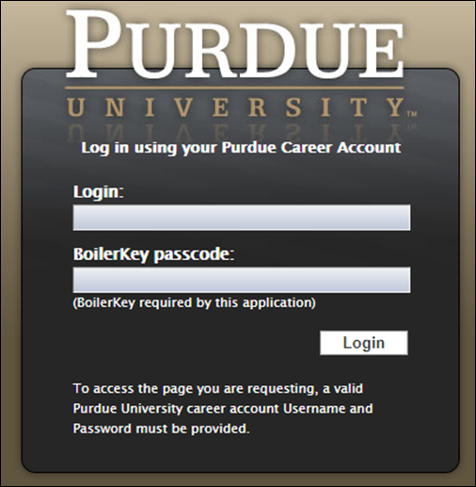

Note for Employees with Multiple Appointments
If you hold multiple positions, use the Change Selected Employment menu to select the position for which you would like to record time | 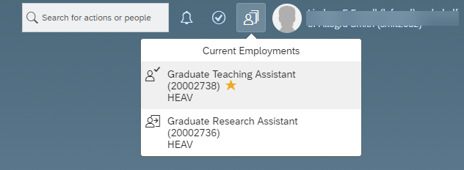
If you hold multiple positions and they are similarly named, click My Profile to validate that the correct position has been selected | 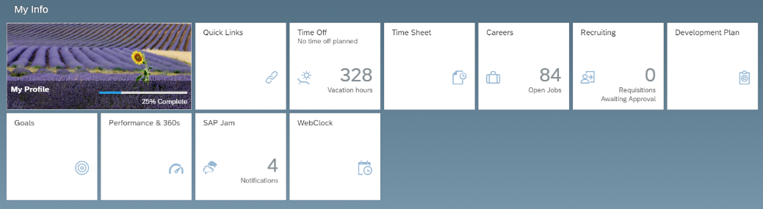
If you hold multiple positions and they are similarly named, click the Employment Information tab to view the details of the position selected in order to ensure time off is requested for the correct position.  Click the Home icon at the top of the page to return to the SuccessFactors home page. | 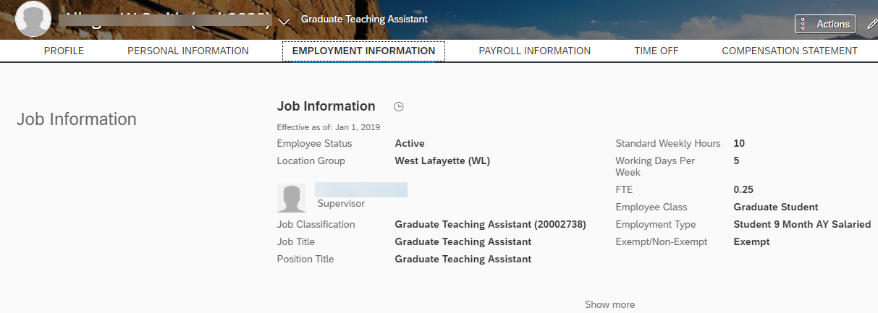

Accessing Time Off Module / Screen Overview
After logging in to SuccessFactors and selecting the appropriate position (if applicable) scroll down to the My Info section and click the Time Off tile |  |  | 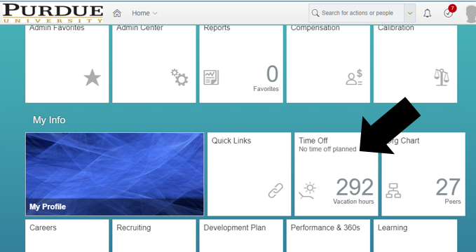
- Balances as of <<date selection>> are shown across the top of the screen.  - Use the Other drop down to view more leave types.  The appropriate leave types based on your employee class will be displayed.  Note: If you have approved leave requests in the future, change the Balances as of date to a date past those approved leaves to view your “true” balances (less any future takings). Moving the date will not add to the balances due to projected accruals.  The system will not allow you to request Time Off if you do not have, at the time that you are submitting the request, a sufficient balance (of the leave type you’ve chosen) to cover the request.  - Use the Team Absence Calendar link to view approved Time Off requests for your peers and direct reports. It may be helpful to view your team’s absence calendar to schedule time off strategically in order to ensure coverage of work responsibilities. |  |  | 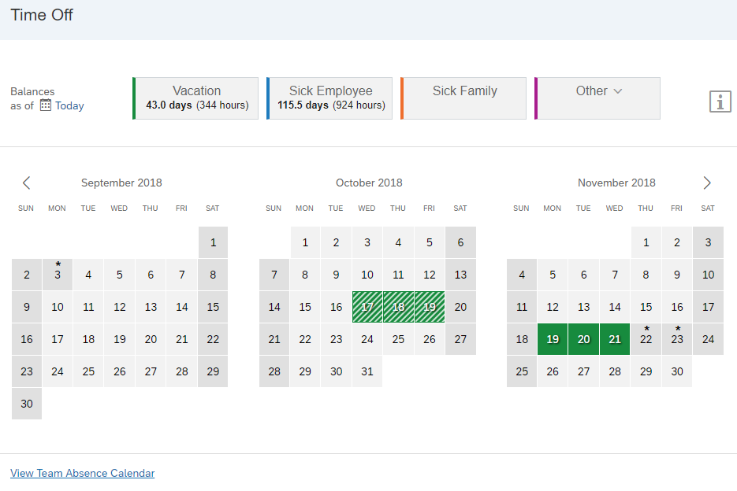  3  2  1

Time Off: Requesting, Editing, and Cancelling Requests
- Select Leave Type:
Click on the box representing the leave type you would like to take (next to the Balances as of… line), or select the leave type from the Time Type drop-down menu.
- Dates:
Use the fields beneath the calendar (or use the paint brush to indicate dates on the calendar boxes) to enter the dates.
Note: Leave requests of less than a full day must be made separately. Employees who do not clock in and out daily will request partial time off in hours and tenths. Employees who do clock in and out daily will request partial time off using exact hours in military time.
- Employees who utilize Positive Duration or Webclock time entry are encouraged to wait until they have recorded their working time for the day on which they plan to request partial Time Off before submitting their Time Off request. This will avoid errors and need to re-submit requests if the amount of working time is more or less than expected.
Example: Seth would like to request vacation for half a day on Wednesday and all of Thursday and Friday. Seth must submit one request for the Wednesday half day and another for the full days, Thursday and Friday.
- Upload Attachment: Used to add any supporting documentation (Example: Jury Duty summons, Military orders)
- FMLA: Select YES in the FMLA drop-down field to request FMLA.
- If this is your initial FMLA request – The Case Number (next field) will be supplied to you by the HR Leaves Group once FMLA request is received. The case number should be left blank for the initial request.
- For all future FMLA time off requests, include the case number provided by the HR Leaves Group.
- Comment: Enter any information you would like to provide to your supervisor.
- Cancel: Clears all fields; request does not move forward.
- Submit: Submits request to your supervisor for approval
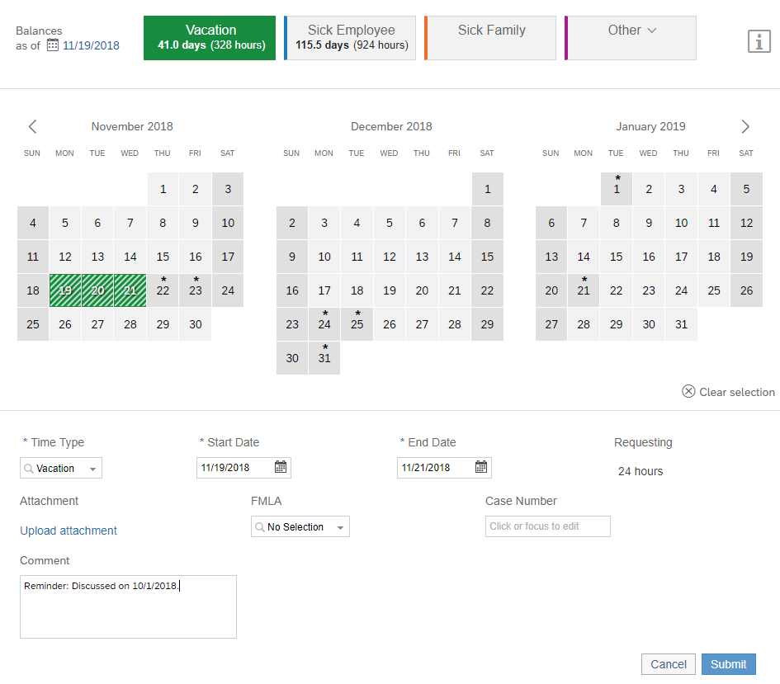
4
5
7
6
4
3
2
2
1
After submitting, a notice appears stating that your request is pending approval by your supervisor. They receive an email notification that your request has been submitted.  The request is also now visible in the My Requests section at the bottom of the Time Off screen. | 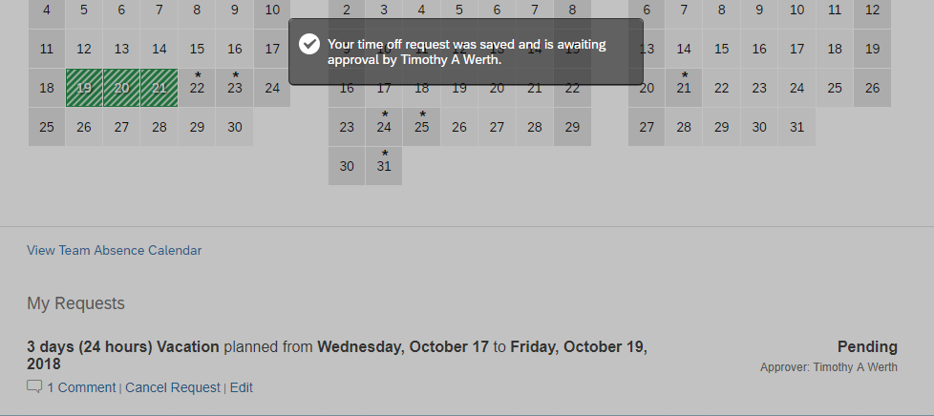
Once a leave has been approved, the status will change from Pending to Approved.  If you or the approver added a comment, it will be displayed by the Comment hyperlink under the leave request title. Click the Comment link to expand the box and view the comment and respond, if needed. | 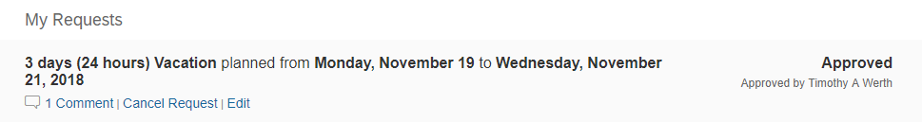
The My Requests section can be used to:  - View the Status of Your Current Request(s)– approved, pending, or denied.  - Cancel Requests – click the Cancel Request link under the appropriate request to cancel. Routed for supervisor approval only if the original request was already approved.  - Edit Requests – click the Edit link under the appropriate request to be taken to the original request screen to edit the details. Routed for supervisor approval only if the original request was already approved. | 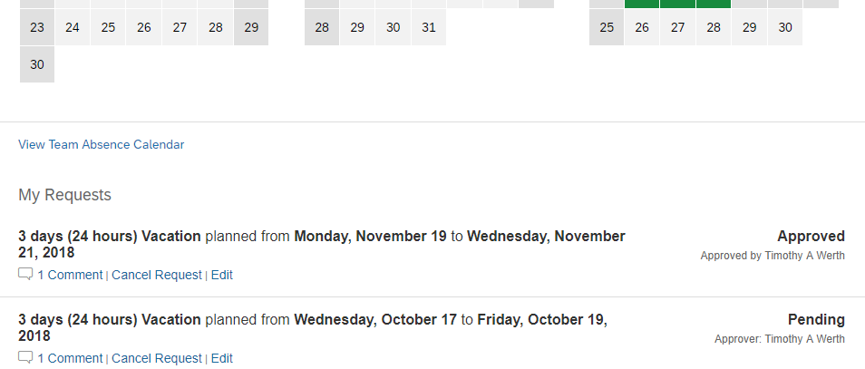  Status

