Greetings!
The transformation of Polytechnic programs is guided by several challenging goals. The SOET is challenged to increase “the percentage of undergraduate courses delivered predominantly with “active learning” instruction from 43% to 60% during the spring of 2017, and to 75% by the fall term of 2017”.
The SoET faculty are known to be great teachers. This program as a way to help faculty develop their skills and contribute to the transformation of the programs in the SOET. This is NOT IMPACT, but it can be even better for the faculty because of its self-paced design (my opinion). This workshop series also creates a special opportunity for interaction and collaboration among the faculty. The focus is on improving course designs and the delivery of undergraduate courses.
The workshop series that follows is for Faculty teaching in the School of Engineering Technology to meet that transformation goal and to continue to develop the Faculty’s active teaching skills. This work was developed from an active learning series for Statewide faculty completed in the spring of 2017. The material is important to all faculty, regardless time or rank. Active learning is not a new concept in technical education. Keeping up to date with methods and technologies that support or transformation is important for all faculty in the SOET.
The lessons and recorded workshop sessions were developed and recorded using WebEx. Supporting materials include selected articles, materials from the IMPACT sessions, inputs from the ITAP instructional design experts, and most importantly, inputs from the participating SOET faculty members.
The IMPACT (active learning) body of knowledge is extensive. The self-paced workshop presents the following topics supported by the recommended articles and videos from IMPACT:
Session 1 – Outcomes and Objectives: The readings and discussion present the education science view of outcomes and objectives. You have probably seen some of this before, but the IMPACT view is a little different than ABET. This session will challenge you to think of what you really want your students to learn from your course.
Session 2- Assessments: This session focuses on alignment. It is essential that the assessment methods used in a class are measuring the stated outcomes and objectives. It’s easy to test and measure something that is not part of the objectives.
Session 3 – Student-Centered Learning: This set of materials concentrates on the pedagogic strategies found in the education research literature. If you are not convinced that active learning is beneficial, you will be after this module. There is so much information provided that a “prep” presentation was made to help you navigate through the readings. The interactive discussion with the faculty concentrates on a sequential model for designing instruction. Although this model is no longer a focus of IMPACT, it presents an “engineering” approach to learning design that makes a lot of sense.
Session 4 – Student Centered Instruction: This session wraps up the extensive literature review of active learning and starts to focus on applying the methods in classes… problem-based, project-based, case-based, and team-based models. The work of Richard Felder at NC State University is a focal point of this material. A short prep presentation introduces this material and an interactive discussion pulls ideas from the faculty together.
Session 5- What will you do to get there? Again there is a lot of material to consider and there are two short prep sessions to help you through what is provided. The focus in on getting new methods into your classes. The interactive discussion with the faculty for session 5 is particularly “active” as faculty present what they are doing.
Session 6 – Presenting your changes in a poster: A great way to share your ideas is through a poster presentation. Opportunities to share your ideas as a presentation and a poster come up frequently. This presentation provides an example of how you can design a presentation in PowerPoint and use that structure to build a “story board” into a poster.
Session 7 – Scholarship and Active Learning: The focus for this session is “closing the loop” – getting your good work written up and published. Too often we never get to this step. The prep session sets the stage for the interactive discussion with the faculty. Key elements include examples of education research and building an education research plan for your teaching.
Special Session 8 – Competency-based Education: This is topic of interest that goes beyond the IMPACT-based materials. There are two short prep presentations to introduce CBE and the new degree framework for Transdisciplinary Studies in Technology and in Engineering Technology. The interactive discussion features a Q&A format featuring Jeff Evans and several faculty members. This session will give you a look into this interesting option for students and some new ideas for describing “competencies” and assessment in your classes.
The point of entry into the workshop materials is the “Active Learning Workshop” site on Blackboard. Faculty and staff in the SOET in April 2017 have been added to this site. It should appear on your listing of Blackboard courses at the bottom of the list of “No Term Assigned” sites.
The entry to the Active Learning Workshop site is shown below…
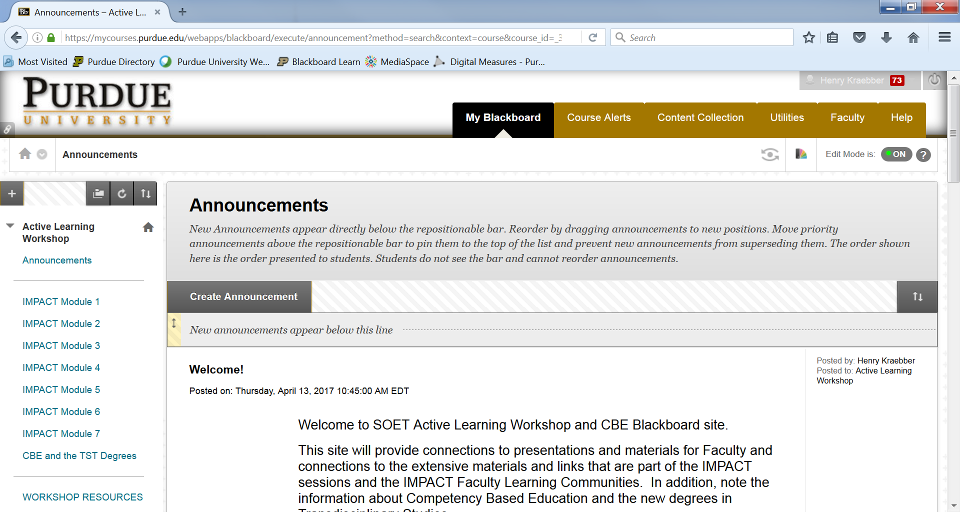
The list of IMPACT modules that provides links to the materials for each session is displayed in a column on the left hand side of the screen. Open Module 1 and you will find written descriptions and links to the module materials as shown below.
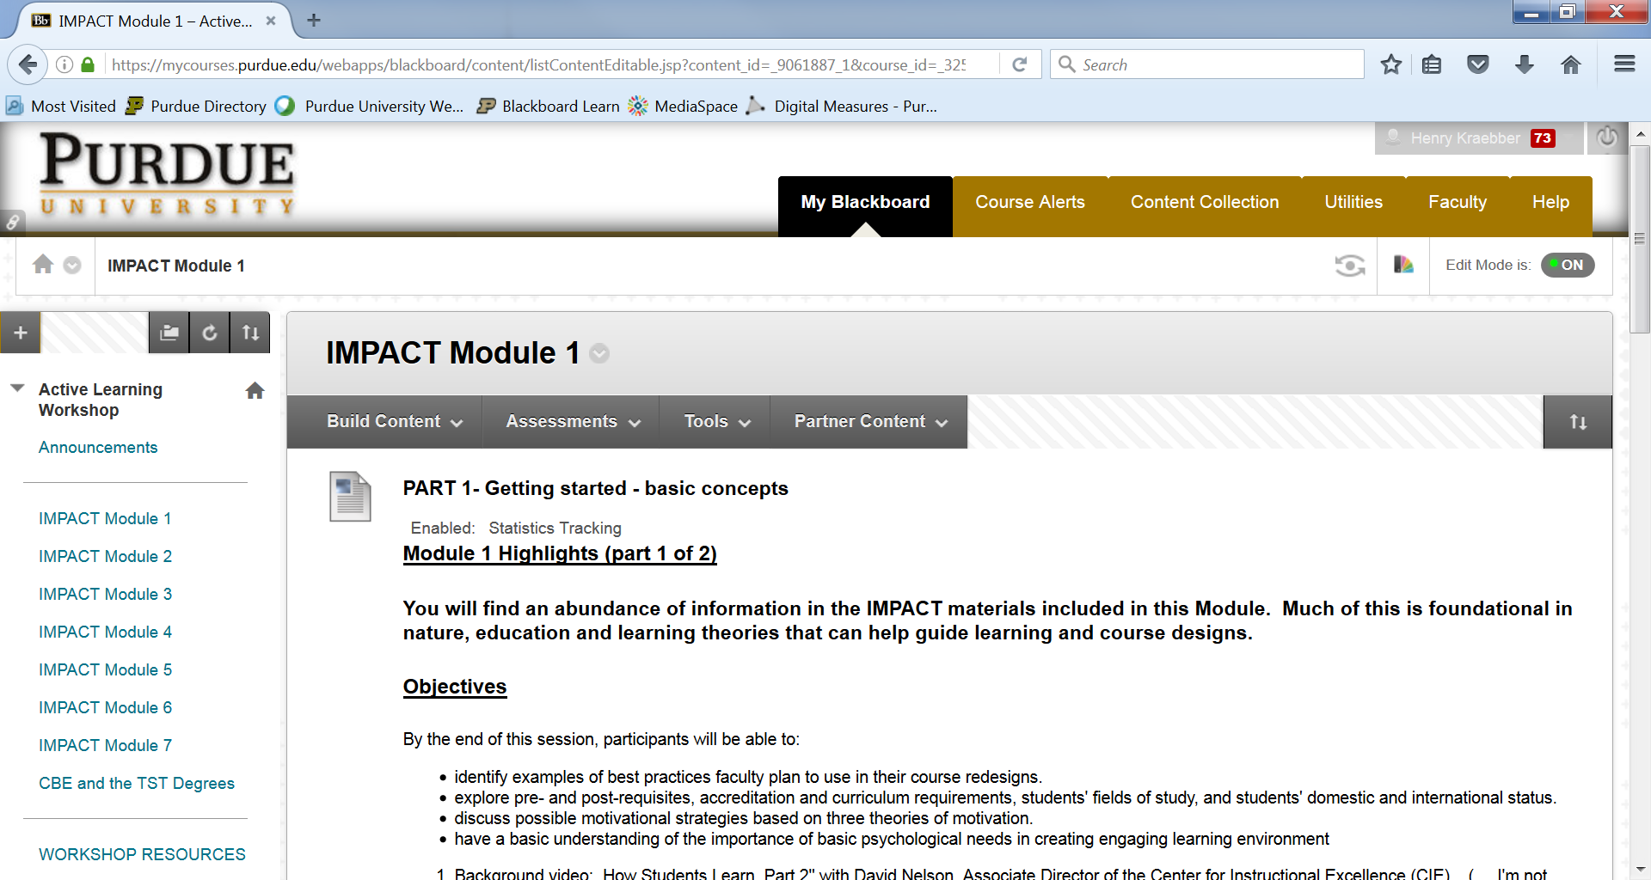

A special set of Workshop Resources is linked below the IMPACT modules. Open this link to find additional information. The first folder link (and perhaps most important folder) provides access to the session presentation recordings and slides, any related prep presentations. Additional folders contain links to related topic areas:
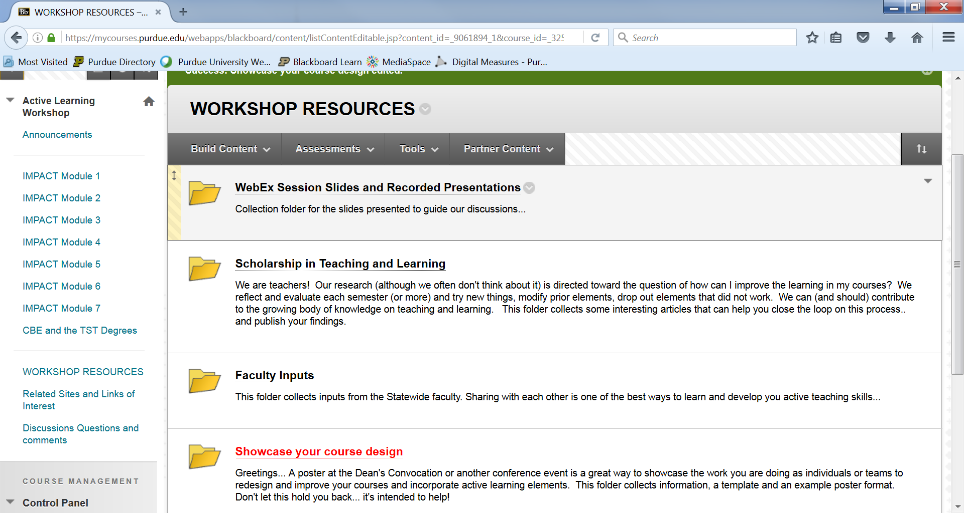
The WebEx Session Slides and Recorded Presentations folder provides you with direct access to the interactive discussions with the faculty, the prep presentations and the slides (without narration) for each presentation.
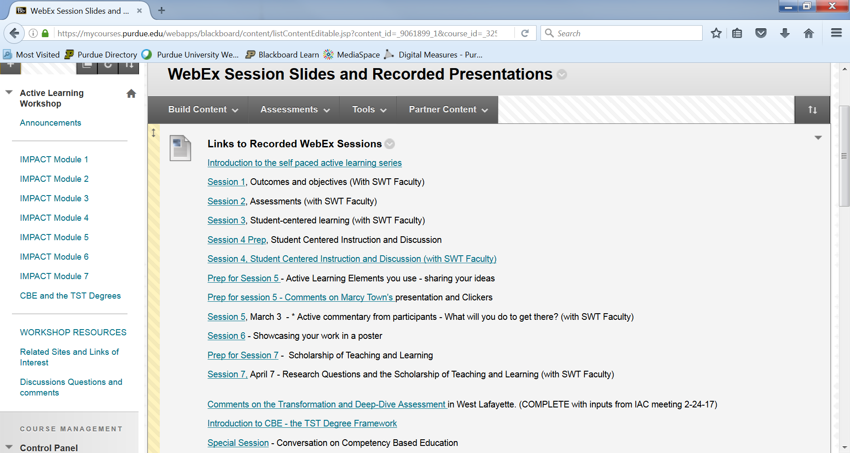
The image below shows the links to the slides without narration. This is a continuation of the previous image…
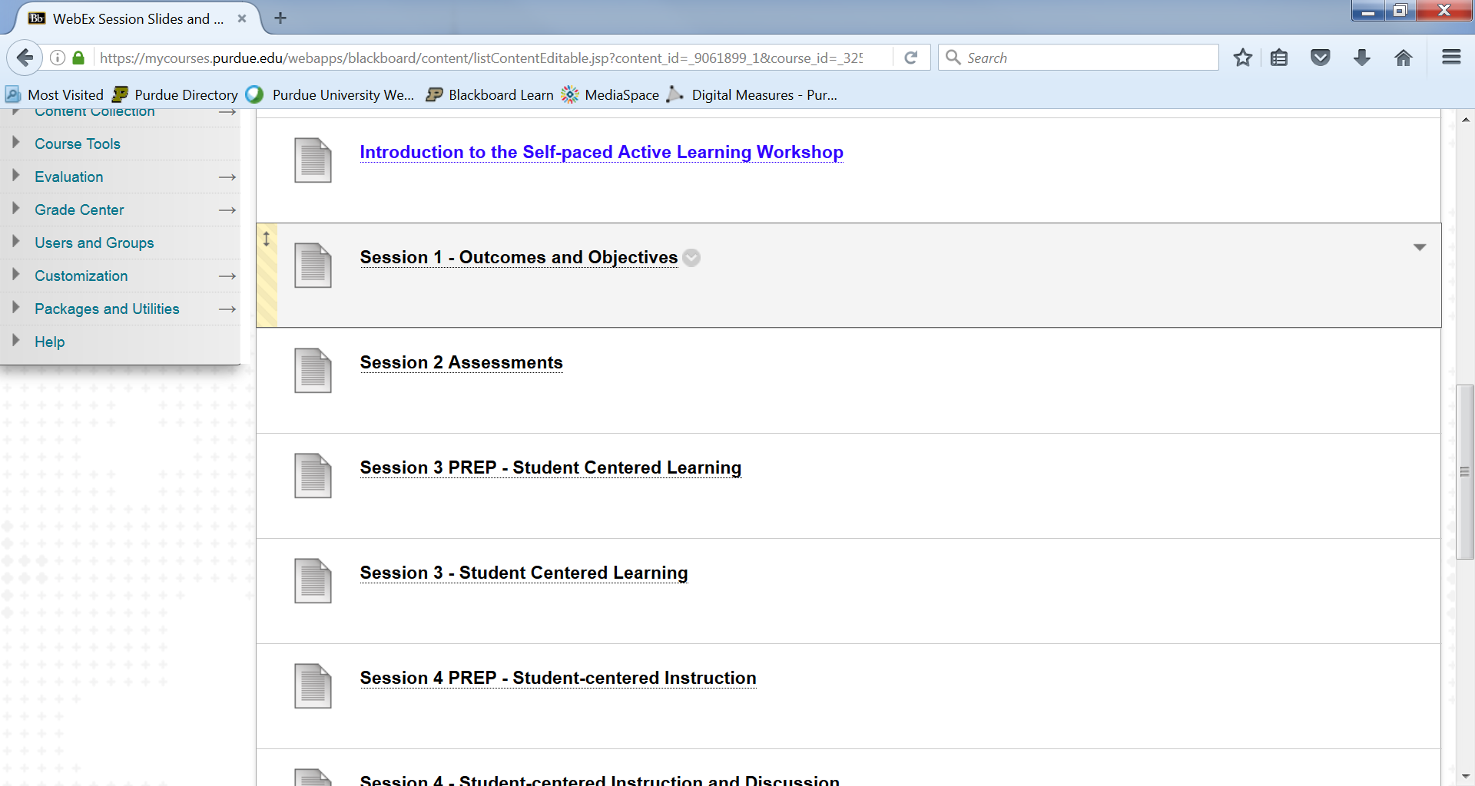
An additional link below the Workshop Resources folder is Related Sites and Links of Interest. Sometimes finding and following links from the IMPACT materials can be difficult. The articles of interest folder contains direct links to some of the best papers from IMPACT as well as additional materials that you may find of interest.
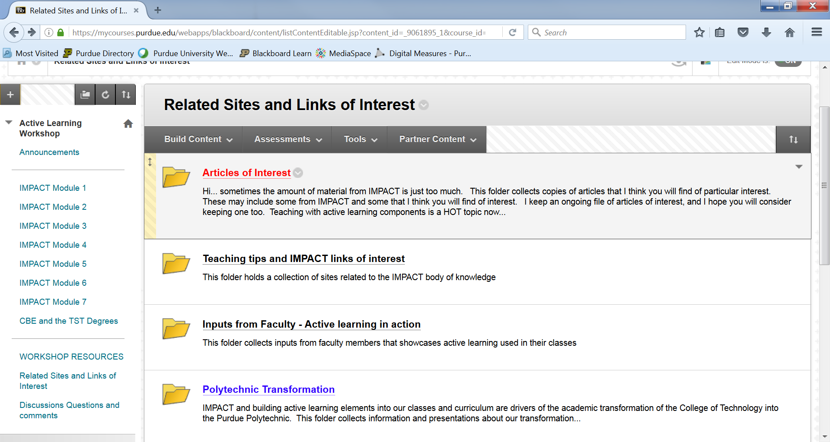
I encourage you to take a look through this site and take advantage of this self-paced opportunity to develop or refresh your knowledge and skills related to active learning.

Thanks for taking time to look this over…

Henry Kraebber, Professor
Purdue School of Engineering Technology

