Spain Design and Construction Integration Study Abroad to Barcelona and Valencia

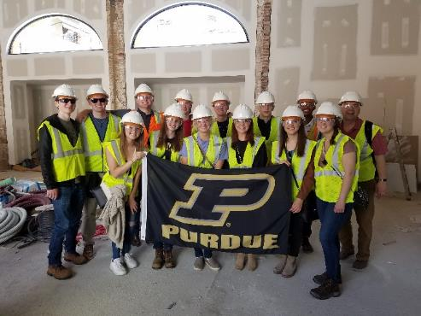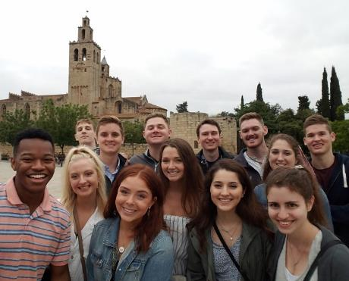

March 9-17, 2024, Spring Break

Perfect for art and design students as well as anyone interested in history or the global impacts of the built environment

Benefits:
- Work with Spanish students at Universidad Politécnica de Valencia (UPV)
- Tour noteworthy ancient, gothic, and modern architectural landmarks
- Sample the nature-inspired ‘modernism’ of Antoni Gaudi
- Explore new design and construction techniques being used in Europe
- Earn 3 Purdue credits
- Fulfill a global requirement.
- Eligible students may be able to offset costs with a $800 - $1,500 Purdue Moves Scholarship.

Preliminary Cost Estimate ~$1,100 + Airfare

Program Leader
Professor Bryan Hubbard, School of Construction Management Technology
bhubbard@purdue.edu

